Oskar Abian
5/29/19

Reflective Essay
With my CEP career nearing completion, it is important to reflect back on the two years I spent in this extremely unique and impactful program. I originally applied to CEP because it was the best UW had to offer for an undergraduate urban planning education. However, the major pressed me to expand beyond this narrow focus by providing opportunities for me to incorporate all of my skills and passions into my education. It made me realize that learning extends beyond the classroom and helped me create a vision for the future I didn’t have when first applying. I will use this essay to reflect back on my time in CEP, the valuable lessons I learned through my experiences in the major, and how they can inform my future pursuits.
Urban planning has long been one of my strongest interests. This was true throughout my childhood but especially during my High School years, where I became more aware of the changes occurring to the City I had grown up in. Unfortunately, I didn’t see many educational opportunities available to study urban planning as a discipline. When looking into the UW during my senior year of college, I came across the CEP major and URBDP minor and saw a focus on topics that interested me greatly. I decided that I would try out urban planning classes once at UW to see if I wanted to pursue it further.
Coming into college, I did not have a clear academic path in front of me. I signed up for a FIG my first quarter that consisted of an intro level writing and political science course. After getting to know some of the other students in the group (who included members of the CEP class of 2020 and 2021), I realized that a good portion of them had already decided on the path they would take both in terms of an education and career. I perceived this as extreme narrow mindedness and lack of curiosity that someone would have made these massive decisions this early in their college education. I resolved to not rush into any specific academic path and instead take my time to explore a variety of subjects that interested me.
In winter quarter, I took courses in Political Geography, Urban History, and Natural History as part of this exploration process. I met Nyles Green in my urban history class and soon realized we had many of the same interests related to urban planning. Midway through the quarter he told me he had applied for CEP, which reminded me of my original intention to try out urban planning classes. The next quarter, I again enrolled in a wide variety of classes, exploring international relations and linguistics, but made a point to include URBDP 200, which introduced me to many of my future CEP classmates and was taught by Mark Purcell. I thoroughly enjoyed the class and taking it convinced me to apply for CEP, which I finally did over Memorial Day weekend. I understood that I had applied extremely late to the program and was prepared to wait another year before reapplying, but luckily was given an interview in July and was offered a spot in the upcoming year’s cohort soon after.
I entered CEP expecting it to be mostly urban planning focused, not quite realizing its major emphasis on interdisciplinary study. I was intrigued to hear about my cohort’s varying interests during orientation, but was slightly concerned that the major wouldn’t have the same level of focus on planning that I did. 301 did not help with this regard, as I originally thought its centering around critical reading and analysis of classical philosophy would leave me disengaged. However, the superb structure and organization of the class content and the contributions of Mark, the instructor, led me to appreciate the class and gain a lot from it. Eventually I got in the routine of readings, assignments, and facilitated discussions, all of which I felt I was improved on through the course of the quarter.
In addition to class, my first quarter of governance played a huge role in bringing me into the major. I decided to join headlights as it seemed like the most impactful committee with a focus on issues of planning and policy that intrigued me. I immediately got involved on a project with several other Juniors of scanning and copying documents from CEP’s past to create a comprehensive understanding of the history of the major. This was hugely important in helping me better understand the original purpose of the major and how it had grown and developed to better achieve its goals. I was extremely pleased with the communal, self-governing structure of the major, which was an aspect I was not as well aware of coming in.
To me the first quarter seemed almost idyllic in the sense that everyone seemed engaged and enthusiastic to work together for the betterment of the major. Winter quarter was a much more difficult time in the sense that everyone seemed to be falling into the grind of classes and the energy seemed to have died off. In contrast to 301, which was superbly orchestrated, 302 felt directionless and uninteresting. The issues of the class contributed greatly to the loss of energy I felt in the quarter. I also took CEP 498 this quarter, which provided me with more of a connection to real life planning. I ended up working on a project with two CEP seniors in my home neighborhood of Beacon Hill. This was my first experience in the world of planning, which I found could be extremely difficult and disappointing yet exciting and rewarding at the same time. In governance, I my efforts started diminishing near the end of the quarter and I decided to refocus my energy the next quarter into a curriculum review of 302.
I was looking forward to spring quarter and taking 303, which was more directly related to my urban planning focus than the previous core classes. The class began with a lot of excitement at the process of engaging in real world planning projects. It had a defined structure and progression, but often seemed like it was trying to do too much without a cohesive vision. This proved to be frustrating at the time of taking the class, with a quick succession of projects thrown our way that seemed only loosely tied. After taking 303, I look back on it fondly, as I’ve realized the work we did was challenging but ultimately meaningful. At the same time, I applied for and was offered a summer internship doing GIS work for SDOT, which I intended to use for the CEP internship requirement. I showcased my experience from CEP to great effect in obtaining this opportunity, which I felt made it extremely rewarding.
My Senior year fall quarter was a time where I was able to regroup and more fully realize what I wanted out of my education. 460 was an enjoyable class and built nicely off my experiences in 303 and 498. While it did seem rather disconnected from the rest of the core classes and limited most collaboration to one’s own project group, the project management and group work skills I developed in this class were extremely valuable, especially moving into my senior project. In governance, I followed through with a review of 302. I worked with a small team to compile feedback received the previous year, present a list of suggestions to the instructor, and organize an introductory event and climate survey for incoming Juniors. During this quarter, I began to develop my plan for finishing school and thinking about my life afterwards. I decided to pursue a double degree in geography to solidify my knowledge of GIS, which proved to be a highly marketable skill. I also ventured into the world of graduate classes for the first time, enrolling in RE 510, which I thoroughly enjoyed. Regardless of the progress and long term planning I accomplished, I did not invest enough effort into my senior project during this quarter and felt extremely behind entering Winter.
My first priority of Winter quarter was to make up lost progress on my senior project. By this time I had a firmly entrenched topic and some sense of a research question with some primary research completed. I began organizing meetings with planning officials from around the Seattle area, a skill I had developed in 460. With their input I got a much better sense for the major issues surrounding annexation in the region and zeroed in on a final research question I would base my project around. I received an unexpected amount of help in this process by learning the basics of writing a research paper in GEOG 315, a geography requirement I was taking at the same time. By the end of the quarter I had a working outline of my final product of my project and was ready to begin working on it in spring quarter. 461 in many ways felt like a repeat of 301 but with more student autonomy and a broader focus on societal issues. Although it felt slightly diminished due to the weight of the senior project, I found the class intriguing and worthwhile.
I set aside my Spring quarter as a time to get necessary work accomplished to finish out my CEP career. I began working on my final report for the senior project early in the quarter before taking a break to work on the presentation. Getting back into the rhythm of work was difficult. I felt much less motivated during the last couple weeks of the quarter and had to put in a lot of effort near the end to finish my work. Overall, I am happy with how my senior project turned out and the learning experience it brought me. It gave me a much greater understanding and appreciation for the role of local government and forced me to thoroughly investigate several intricate policy issues. The most valuable lesson I learned was how to plan out and follow through with an independent project, both in the conceptual and practical realm. I am also extremely proud of my work in governance over this quarter. I spent my time working on a variety of projects. These include proposing and passing an amendment, working on the internal headlights amendment process guidelines, creating policy ideas for a strategic plan, and writing policy into the plumb manual. I participated in both applicant review days and several steering meetings and found my increased participation in the major quite gratifying and helpful in developing stronger bonds with other students.
Although I didn’t make any summer plans, I am very excited for this upcoming time. Firstly, I will be continuing my senior project by finalizing my report and working with community groups in White Center to make it public. It has been very interesting getting involved with the local politics of White Center. I would like to work more with this community and other like it in some capacity. I have made connections in the Seattle, King County, and Bellevue governments, through both this project and LCY, and would like to explore ways I could leverage my work into official positions in government for the longer term future. This summer, I plan on getting involved in politics through practical means like grassroots activism. Through my time in CEP and discussions with students like Aidan Carroll, I became aware of multiple important causes just in the local area, which I feel are worth getting involved in to actually make a difference.
CEP taught me many invaluable lessons. First and foremost, it exposed me to a wide range of viewpoints and interests and taught me the value of keeping an open mind while maintaining a critical analysis of the surrounding world. I learned to embrace a wide range of interests and incorporate knowledge from any and every source. The student driven nature of the major and self driven nature of the ISP helped me improve my ability to take initiative in my own learning. This skill is critical in my future education and employment and can help me in many other aspects of life. Participation was not voluntary in CEP. For the major to truly work, I realized that all members needed to be actively contributing to it. This is extremely difficult to force but when it happens organically it is an extremely powerful and gratifying feeling. I believe success in CEP comes from staying grounded in one’s own values while constantly pushing their boundaries in terms of skills, interests, knowledge, perspectives, and effort, which often involves leaving their comfort zone in some fashion.
One of the most important factors in my college experience was that throughout of all of it I remained active in several different fields of interest. I found venues to express the various hobbies and skills I had built up rather than letting them atrophy. I was involved in music through wind ensemble throughout my entire time in college. This provided me a constant creative outlet, exposed me to people from the music department and several other backgrounds, and gave me a venue to continue honing my skill and pushing my boundaries as a clarinetist. Through Ultimate frisbee, I had an athletic outlet in which I developed strong bonds with my teammates and took on a leadership role on the field. I was also active in the Model UN and WashPIRG clubs, which provided academic and social opportunities that I wouldn’t have had otherwise. Overall, my involvement in a variety of activities helped me stay grounded in my interests, provided an outlet and distraction from school, and brought me in contact with a diverse range of people.
Over my time in college, I began to grow weary of the traditional class structure and found it to be much less effective in my engagement and learning as time grew on. From both working and my senior project and seeing others’ I realized that I needed to take more initiative and responsibility for my own education in the future. In my opinion, this requires a level of autodidactic discipline I would like to develop in my time after college. I want to explore a vast array of topics through reading, self-instruction, and independent projects that can help make me a more well rounded and self-sustaining learner. This also extends into my skills and the activities I pursue. I think this also requires becoming a much more well organized person. I unfortunately found that during my time at my internship over the summer that my entire day was being consumed by work. I didn’t feel like I was using most of my time in a meaningful way. I hope to develop strategies to avoid this and make time for my interests and learning outside of work.
After the summer, I will be returning to school for one more quarter to finish out requirements for my Geography major. I will be officially done with college entering into 2020. At this point, I hope to have some experience volunteering and working for different organizations and causes and begin working in some capacity on a political campaign for the upcoming 2020 election. My ultimate goal is to establish a career in urban planning, but in the meantime I hope to try out a variety of different fields. I hope to travel, work in the private/nonprofit sector, and continue learning independently before settling into a career path or deciding to pursue a graduate education. The next couple years are shaping up to be an exciting and transformative period in my life and I hope to make the most of them.

Artifact 1: LCY Poster
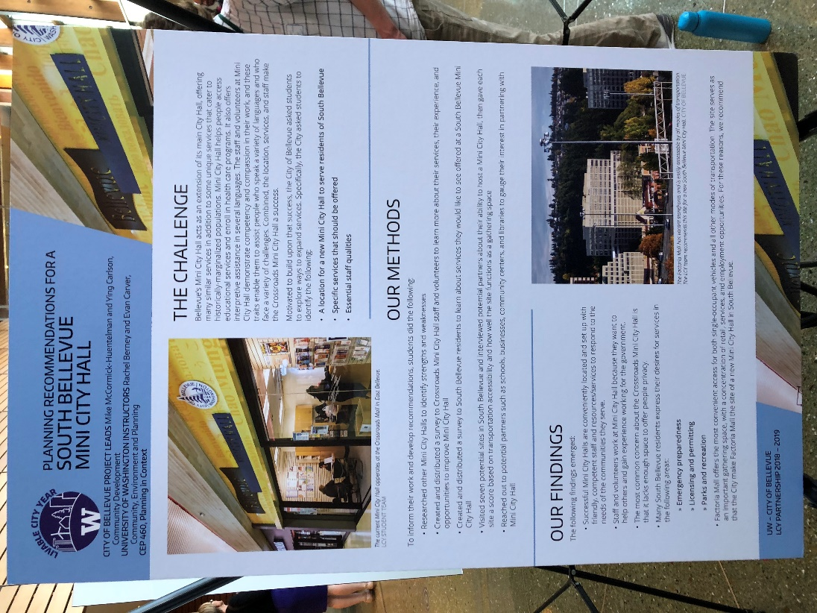
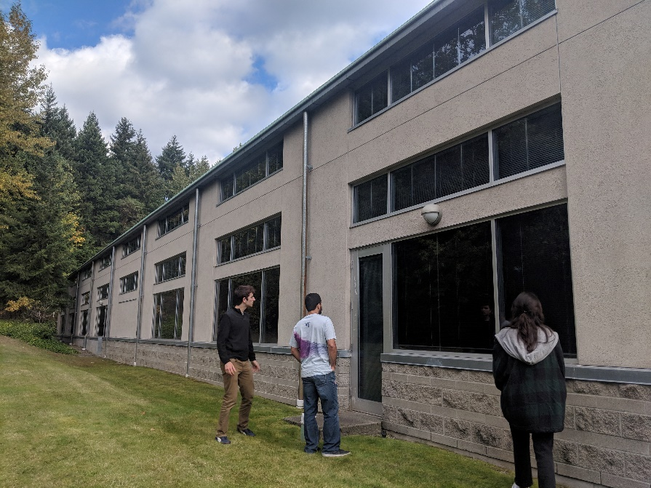
Artifact 2: Senior Project Night Presentation
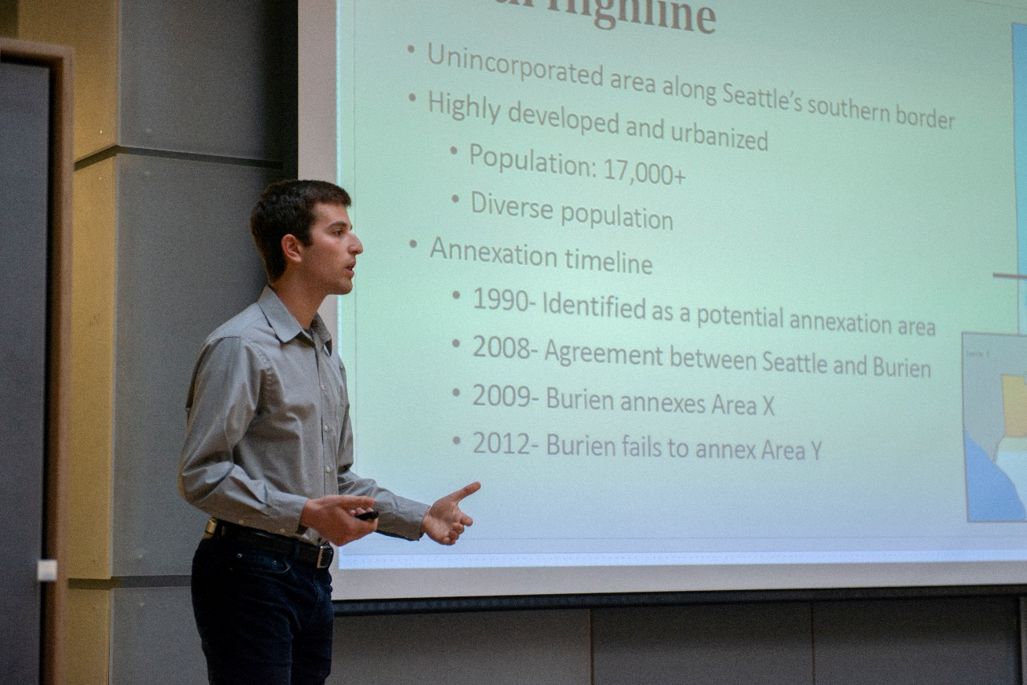
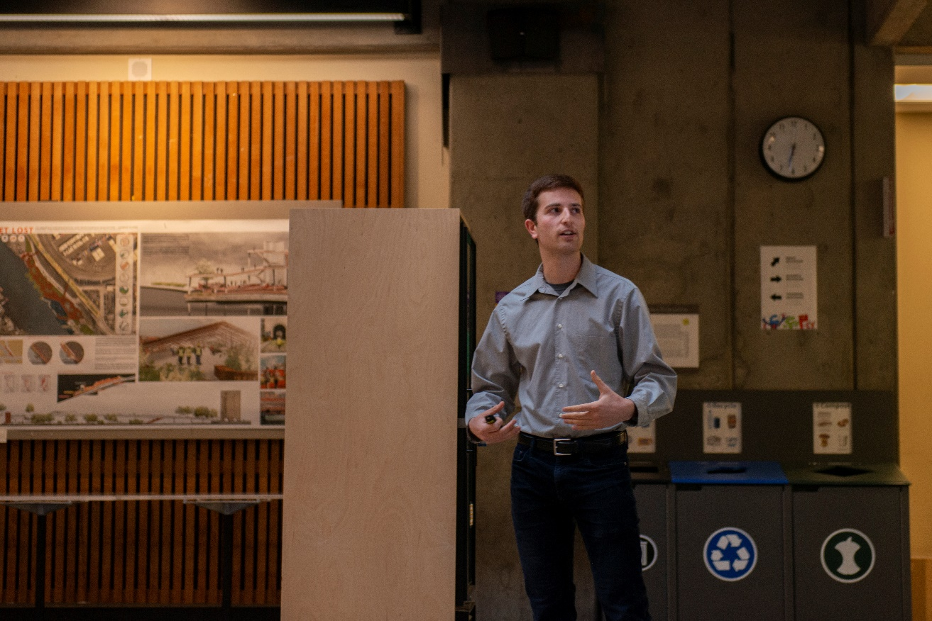
Artifact 3: CEP 446 Variable Credit Amendment
Amendment Proposal - CEP Plumb Manual.

Name: Oskar Abian

Proposal Title: CEP 446 Variable Credit

Date Proposed: 4/26/19

Predicted Timeline: Vote on 5/3/19

Goal: Change CEP 446 to a variable credit class (1-5)

Proposal Description: (1-2 short paragraphs)

Change CEP 446 to a 1-5 variable credit class. This change will be reflected in the plumb manual, course description, class registration, and the internship requirement.

Why are you proposing this amendment?

As it currently stands, CEP 446 is a 5 credit class. Even though the actual work in class does not justify 5 credits, the idea is that the time spent working at an internship makes up for this disparity. However, because the class does not require students to be currently working in an internship, many people take it after having completed their internship in the summer or a previous quarter. For students in this category, the work done in the class is not equivalent to 5 credits and can often overload their credit limit for the quarter. Currently, many students end up having to audit the class or drop other classes they wish to take. I am proposing this amendment to make the class a variable credit to eliminate this issue. Students are still able to take the class for 5 credits, however, those who do not may simply reduce their credit load rather than auditing the class. This also allows students to save money by paying for fewer credits during a quarter, offering a level of financial flexibility that promotes equity.

What, if any, committees will be involved in your proposal?
Headlights

