

City of Bellevue

South Bellevue Mini City

Hall Final Report

University of Washington

College of Built Environments

CEP 460: Planning in Context

Instructors:

Rachel Berney

Evan Carter

City of Bellevue Project Leads:

Ying Carlson

Mike McCormick Huentelman

Student Authors:

Oskar Abian

Vivian Chan

Nyles Green

Iliana Gutierrez

Emmanuel Salinas

Fall 2018

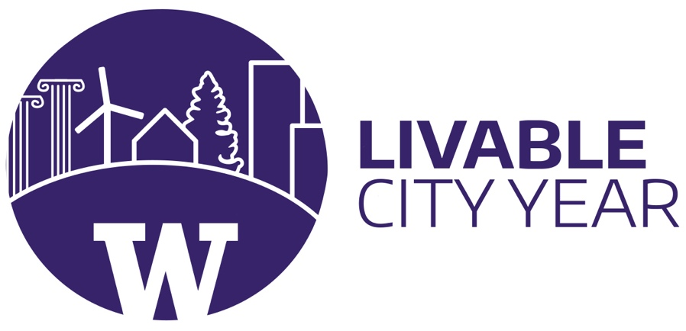

LIVABLE CITY YEAR 2018-2019

IN PARTNERSHIP WITH

CITY OF BELLEVUE

**ACKNOWLEDGMENTS**

We would like to express our sincerest gratitude to the participants who completed our online surveys and provided valuable insights. The participants’ willingness to impart their thoughts and sentiments helped to advance the depth and reach of this report. We would also like to thank the community stakeholders who took the time to talk and meet with us, including:

Blanca Lujan Westrich

Community Advocate Coordinator

ICHS

Miran Hothi

Community Advocate

ICHS

Mercedes Córdova-Hakim

Eastside Cultural Navigator Program Manager

CISC

Sapan Parekh

Associate Director

Service-Learning & Community Engagement, RISE Learning Institute, Bellevue College

Debbie Lacy

Executive Director

Eastside Refugee and Immigrant Coalition

Jen Newton

Manager

South Bellevue Community Center, Bellevue Parks & Community Services

Inger Johnson

Vice President

Leasing and Asset Management, Kimco Realty Corporation

Kalin Berger

Operations & Development

Regency Centers

Lastly, we also would like to thank Ying Carlson and Mike McCormick Huentelman from the City of Bellevue for their support and assistance throughout our study. Ying and Mike provided important background on the city of Bellevue, met with us several times, and overall were instrumental in the development of this project.

**TABLE OF CONTENTS**

|  |  |
| --- | --- |
| About Livable City Year  Executive Summary  Introduction  Methods  Analysis  Case Studies  South Bellevue Demographics  Outreach Results  Implementation  Preliminary Locations  Criteria Definition  Location Analysis  Recommendation  Conclusion  Appendices  References  **Permission to use**: This report represents original student work and recommendations prepared by students in the University of Washington’s Livable City Year Program for the City of Tacoma. Text and images contained in this report may be used for not-for-profit purposes.  **Recommended citation**: Livable City Year 2018. *South Bellevue Mini City Hall*. University of Washington, Seattle, WA. Prepared for City of Bellevue. | 01  02  04  06  08  08 |

**ABOUT LIVABLE CITY YEAR**

The University of Washington’s Livable City Year (LCY) initiative enables local governments to engage UW faculty and students for one academic year to work on city-defined projects that promote local sustainability and livability goals. The program engages hundreds of students each year in high-priority projects, creating momentum on real-world challenges while enabling the students to serve and learn from communities. Partner cities benefit directly from bold and applied ideas that propel fresh thinking, improve livability for residents and invigorate city staff. Focus areas include environmental sustainability; economic viability; population health; and social equity, inclusion, and access. The program’s 2018–2019 partner is the City of Bellevue; this follows a partnership with the City of Tacoma in 2017–2018.

The LCY program is led by faculty directors Branden Born (Department of Urban Design and Planning), Jennifer Otten (School of Public Health) and Anne Taufen (Urban Studies Program, UW Tacoma), with support from Program Manager Teri Thomson Randall. The program was launched in 2016 in collaboration with UW Sustainability and Urban@UW, with foundational support from the Association of Washington Cities, the College of Built Environments, the Department of Urban Design and Planning, and Undergraduate Academic Affairs.

LCY is modeled after the University of Oregon’s Sustainable City Year Program and is a member of the Educational Partnerships for Innovation in Communities Network (EPIC-N), the collection of institutions that have successfully adopted this new model for community innovation and change.

For more information, contact the program at uwlcy@uw.edu.

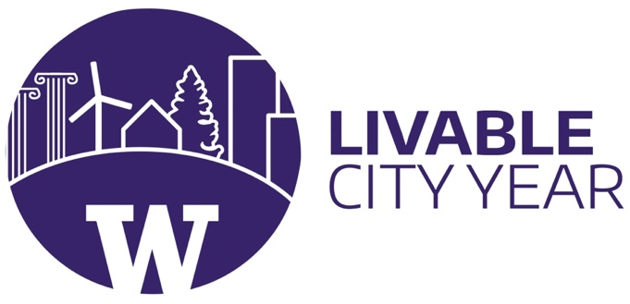

**EXECUTIVE SUMMARY**

**Problem**

The City of Bellevue has determined that South Bellevue residents are in need of a Mini City Hall that is centrally located in the area. Currently, the two other city halls in Bellevue (Bellevue City Hall and Crossroads Mini City Hall) cater to residents who reside closer to their locations, leaving those in South Bellevue without the same access to city hall services and programs.

**Introduction**

The goal of this Livable City Year project is to determine where a second Mini City Hall (MCH) location in South Bellevue should be placed, and what services and partnerships will best serve residents in the area. We formulated a methodology that broke our project into three main sections: analysis, implementation, and recommendation

**Analysis**

To begin, our team looked at Crossroads Mini City Hall as a model, specifically studying the services offered and the stakeholders of that location. We also recognized that the Crossroads MCH is located in a third place, adding to its popularity as a site that residents feel comfortable visiting. We then looked into three additional case studies that analyzed the effectiveness of municipal government satellite locations. We looked at Westfield Southcenter’s Library Connection, Coral Springs City Hall in the Mall, and The Philadelphia Northeast Municipal Service Center, drawing lessons from each we could apply to a new Mini City Hall. We then researched background information on South Bellevue, looking at demographics and community assets in the area. We conducted outreach in the form of two surveys, one for Mini City Hall volunteers and staff and another for South Bellevue residents, as well as interviews with representatives from partner organizations. Through these efforts, we were able to better understand the factors behind the success of Crossroads Mini City Hall and identify the needs of the South Bellevue community and their expectations for a South Bellevue Mini City Hall. Throughout this project, our team conducted several site visits to observe the possible locations for the South Bellevue Mini City Hall in person. From our research, we found that the most important aspects that lead to a successful MCH are that it is accessible, welcoming, and that the services offered cater to the specific community surrounding the area.

**Implementation**

We began our project with a list of several possible locations for a Mini City Hall in South Bellevue, provided to us by the City. We then took the information we learned in our analysis and created a list of criteria with which to evaluate each site in a comparative matrix. From this matrix and our impressions from site visits, we further narrowed down our choices to three final locations: Factoria Mall, Eastgate Plaza, and Bellevue College. We more thoroughly assessed the strengths and limitations of each option to develop a final recommendation for the City of Bellevue.

**Summary of Findings**

We broke up our final recommendations into two main sections: location and services. For the location, we decided that Option 1 of Factoria Mall was the best location for a new Mini City Hall due to its existing user base and accessibility. We found that Factoria Mall was the location that would be able to offer all these elements for South Bellevue’s Mini City Hall. Factoria Mall has several available spaces that could hold a Mini City Hall, and also has the potential to act as a third place like Crossroads Mall. Although Factoria Mall is located in a busy area, it is most fit to host South Bellevue’s Mini City Hall. From our analysis, we found that the most important aspects that lead to a successful MCH are that it is accessible, welcoming, and that the services offered cater to the specific community surrounding the area. We offer several suggestions for services the new location can offer or emphasize as well as community partners in the area that can collaborate to provide services for the community.

**Objective**

The goal of this project is to determine where a second Mini City Hall location in South Bellevue should be placed and what services and partnerships should be offered to best serve the residents in South Bellevue.

This project is designed to promote the overall goals of Livable City Year in the South Bellevue community. Bellevue is growing rapidly, and its population is becoming more ethnically diverse and multilingual. For the past couple of decades, Bellevue has operated an accessible and culturally inclusive facility to provide information and referral services for its residents: the Mini City Hall (hereinafter called the ‘MCH’), located in the Crossroads Shopping Center. MCH offers a wide array of government and community services in an active community friendly setting, less formal than the downtown City Hall, that maintains direct partnerships with a variety of community-based organizations. Because of the success of this program, the city would like to explore and identify additional MCH locations that would better serve South Bellevue residents by improving local accessibility to city services. This report will detail the project process our group undertook and offer recommendations to the City as to the best location and services for a South Bellevue Mini City Hall.

**INTRODUCTION**

**Background**

Bellevue’s existing Mini City Hall at Crossroads Mall opened in 1995 with a mission to provide personalized information referrals and outreach to Bellevue’s diverse population in the East Bellevue area. Although now 23 years old, MCH continues to be a vibrant part of the community. Today, it is well known as one of the best service locations in the Eastside for delivering culturally appropriate, linguistically inclusive customer service, and has built up trust with the underrepresented population of Bellevue.

The City’s population has now grown to be over 40% foreign-born and East Bellevue has seen this transformation first hand. MCH has evolved alongside  the community in the past two decades as well. As a leader in best practices for culturally competent service delivery, MCH serves customers six days a week, including Saturdays from 10am to 6pm. Additionally, it holds office hours in 11 languages with staff and volunteers, and more than 150 over-the-phone language interpretations a week. They have partnered with more than 10 non-profit organizations over the years to respond to emerging community needs. In 2017 alone, the MCH at Crossroads staff has served more than 24,000 people and responded to over 46,000 citizen requests.

Services provided at MCH include city programs and services, community information and referral, multi-language resources and materials, and attention to individual needs and concerns. MCH offers multilingual office hours in Spanish, Cantonese, Mandarin, Russian, Hindi, Bengali, Urdu, and Korean. Staff and volunteers with partner organizations offer referral services in all of these languages in addition to Ukrainian, Punjabi, and Arabic. The Cultural Navigator program focuses on connecting residents with limited English skills with resources and services through MCH.

Through the services they provide and meaningful interactions with the public, MCH has built a foundation of trust between city staff, elected officials, and local residents. The concept of MCH, “bringing city hall to your neighborhood,” has demonstrated its power by successfully engaging with people from all walks of life, especially those who are new to the city of Bellevue or less inclined to interact with the government. Over 20 years, the location at Crossroads has fundamentally changed the way people interact with government. The volunteer program has mentored more than 50 individuals over the past two decades and has contributed countless hours to serve the community. Overall, Mini City Hall at Crossroads is a great model for what a South Bellevue location can be.

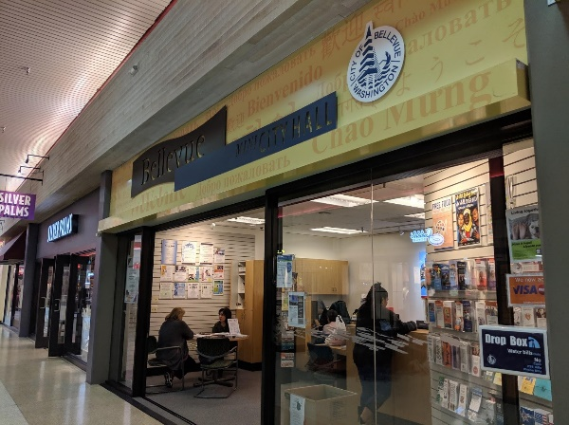 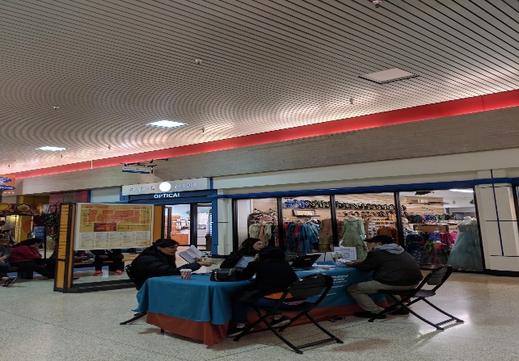

**METHODOLOGY**

**METHODS**

To address the two main questions at the core of our project, we formulated a methodology that would draw from multiple sources of information and methods of analysis to best carry out our intended goals. We broke our project into three main sections: analysis, implementation, and recommendation, each of which contained several tasks we will explain in detail.

**Process**

To provide context for our project, we researched background information on the history of Mini City Hall, investigating its origins and the process by which it has evolved to better serve its functions within the community. We then conducted three case studies that analyzed government municipalities operated satellite locations. We looked into Westfield Southcenter’s Library Connection, Coral Springs City Hall in the Mall, and The Philadelphia Northeast Municipal Service Center in order to gain a deeper understanding of the different elements that play a role in how these locations are run.

Through interviews with staff and volunteers, we identified the main actors involved with MCH. We asked specific questions to better understand the success and improvements needed of MCH so that they may be implemented in the South Bellevue location. Additionally, we interviewed Ying Carlson, the Community Service Supervisor of Crossroads MCH to understand her perspective on the factors that led to MCH’s success. Ying also connected us with representatives from several organizations that currently partner with MCH.

The next major part of our methodology involved conducting outreach. We created two different surveys, one for MCH volunteers and staff and the other for South Bellevue residents. We then focused our efforts on conducting community outreach with South Bellevue locals, community leaders, and active residents. We created a list of contacts, while also collecting extensive notes during meetings and debriefs we had with community stakeholders and representatives of community organizations. From this information, we created a list of community needs and wants for the new MCH and also analyzed what makes the programs and partnerships at the existing MCH successful.

For the asset analysis portion of our report, we focused on researching South Bellevue’s demographics so that we could identify trends to further highlight the needs of the community. We collected and analyzed data on factors such as race and ethnicity, age, income, language, and educational attainment. We identified assets such as nonprofits and other community organizations that exist in South Bellevue. Doing this provided insight into partnerships a South Bellevue Mini City Hall could pursue. We also kept in mind how some of these resources may or may not best serve the South Bellevue area.

For the implementation aspect of our project, we took the information we learned in our analysis and created a set of criteria to analyze the strengths and weaknesses of each site. We began by considering the potential locations referred to us by the City of Bellevue. We visited every site at least one time, and with the comparative matrix we assessed several key characteristics across each location in order to determine the strongest candidates. In addition to the matrix, we also looked at current property parcels and owners in each location, recent and planned development, and used our own observations to begin building a case for each option.

Using our comparative matrix, we narrowed the possible locations to three final options. We presented the strengths and challenges of each in detail, and offered a brief description of the possible implementation of MCH within the site. From our site analysis, we created our final recommendation for the intended location of the South Bellevue Mini City Hall. This section includes thorough consideration of each option presented. Our decision did have a measure of subjectivity, but we hope that our detailed research and analysis can help the city of Bellevue assess each option along with their own priorities and framework. We also offer suggestions for the services and partnerships the South Bellevue location should pursue, based off our analysis of the community’s needs and assets.

**Survey Methodology**

Part of our outreach attempted to understand Mini City Hall (MCH) from the perspective volunteers and staff. Because of time constraints and other factors, we decided our data collection would be best conducted through electronic surveys. Since MCH has considerable volunteer and staff involvement in the day to day operations, we believed getting their perspective would be beneficial in understanding MCH’s interactions with the community. Volunteer and staff input would be used to assess what could be improved at the the Crossroad’s MCH and what recommendations or changes they would make if a second MCH were to be developed in South Bellevue.

The Volunteer/ Staff Survey was created using Google Forms. To begin generating questions, we thought about what information would be relevant to our project if an outsider, like a UW student, interviewed one of us. Some questions addressed basic logistical and contextual concerns such as, “What do you do at Mini City Hall?” or “How did you first hear about Mini City Hall?”, while other questions were a bit more complex when first drafted. The structure of the survey was organized by placing easier, warm-up questions in the beginning, specific and thoughtful questions in the middle, and ending with demographic questions at the end. Once the first draft was completed, the survey went through a round of edits by Evan Carver and a few rounds of edits from Ying Carlson. Carlson distributed the survey by sending it electronically to MCH volunteers, staff, and partners. The survey received a total of eleven responses from MCH volunteers, staff, and partnership staff.

The need for the Resident Survey came from our understanding that a new MCH should provide services that are wanted and needed by the South Bellevue residents. If the City of Bellevue were to replicate the Crossroad’s MCH at a location in South Bellevue, the new MCH might not be as successful or have as strong as a connection to the South Bellevue community if the services and partner organizations were not reflected of the desires of South Bellevue residents. To give the new MCH its best possible chance of surviving, the services and partner organizations need to be reflective of the community it serves. After discussing the purpose of the survey, our group came to the conclusion that the goal of the survey would be to anticipate the types of services and resources that could offered by a South Bellevue MCH.

The Resident Survey was created using Google Forms. We attempted to create a short survey that could be quickly completed by respondents while still providing the information we were looking for. When formulating questions, we tried to include all the different categories of services that residents could use in their everyday life or on occasion. After rounds of edits from Carver and Carlson, our long list of services was narrowed down to umbrella categories that a number of services fall into, with an option for respondents to elaborate on their responses or offer their own suggestions. Residents were allowed to check multiple boxes/ services so they did not feel constrained asking which service their community needed the most and could tell us more broadly what their community needs and wants are. A space at the end of the survey was included to give residents the choice of passing on any information they thought relevant on to us. Carlson distributed the list through Nextdoor targeting South Bellevue residents. The survey received a total of 36 responses.

**CASE STUDIES**

**ANALYSIS**

For the case study element of our Livable City Year report, we look at the Westfield Southcenter Library in Tukwila, WA, the Coral Springs City Hall in the Mall in Coral Springs, FL, and the Philadelphia Northeast Municipal Services Center in Philadelphia, PA. Our methodology to examine these three cases was to study their locations, services offered, and to gauge general public sentiments through platforms such as Yelp and Google Reviews in order to understand the public reception of these places that offer municipal government services at satellite locations. We derived these criteria by drawing from the comparative matrix developed to assess the several key characteristics across each possible location for the South Bellevue Mini City Hall. The purpose of studying these sites is to gain a deeper understanding of the different elements of how these locations are run, and then apply this analysis when making our final decision for the South Bellevue MCH location site.

**Case Study #1: Westfield Southcenter Library**

On May 8, 2004, the Southcenter Library was officially open for business at the Westfield Southcenter Mall. Due to a survey indicating that south King County was in need for more library services, the opening of this library was very popular because of its convenient location and open store hours (with it being open during all mall hours, seven days a week). In early 2012, the Southcenter Library underwent an expansion, making the library a total of 5,000 square feet. Despite being situated in the largest shopping mall in the state, this King County library location has been successful because of its size, accessibility, and comfortable, welcoming atmosphere. Additionally, similar to Bellevue’s current Mini City Hall at Crossroads, Southcenter Library was also established at a third place, making the surrounding environment social, communal, and hospitable.

The Southcenter Library has also found popularity in the programs offered at this location. Visitors may utilize a variety of services that are specific to the surrounding Tukwila community. These services include: help with finding jobs, assistance with advancing careers, support with developing computer skills, help with accessing materials in world languages, and tutoring to improve reading skills. Guests may also use library resources such as printers, scanners, and copiers.

General public sentiment towards Southcenter Library appears to be positive, with reviews on Yelp rating this located 5/5 stars. Out of a total of 9 reviews spanning from 2007 to 2018, Yelp reviewers often commented on the library’s cleanliness, safe atmosphere, and friendly staff. The library’s free programs for both children and adults, and its diverse reading selection were also acclaimed, while the word “diverse” appearing in a couple of reviews.

The Westfield Southcenter Library has found success due to its comfortability, convenience, and community-centered programs and services. With a focus on the surrounding residents needs’, this location is very popular because it is based in a bustling third place and assists the diverse neighborhood that encircles it.

**Case Study #2: Coral Springs City Hall in the Mall**

Opened on October 3, 1984 Coral Square is located in Metropolitan Miami and offers a total of 117 stores and eateries. In 1995, the Coral Springs City Hall in the Mall was established through a partnership with the US Department of State, Passport Division with a goal to “bring Coral Springs government to the people by providing dozens of resources for residents.” Due to its central location, there are a variety of public transportation options, with several bus stops nearby that 3 different bus lines run through. There is also an abundance of parking available, and the site is in the middle of two main cross streets in the area.

Many services are offered at the Coral Springs City Hall in the Mall, which include fingerprinting, garbage and recycling information, fax and photocopy services, notary assistance, and voter registration help. Due to their direct partnership with the US Department of State’s Passport Division, passport services are the most utilized of all the programs offered. According to Yelp reviews, most visitors are happiest with the quick and easy process of obtaining and renewing their passport at the City Hall in the Mall location. With a Yelp rating of 4.5/5 stars from 10 total reviews, the most frequent comment posted was the staff were not only helpful and friendly, but also that the location of this city hall was at a very convenient location. Overall, general public sentiment towards this government municipality was positive and enthusiastic.

The Coral Springs City Hall in the Mall offers a variety of services, among the most popular being the passport ministrations. The friendly and helpful staff, as well as the convenient location, makes this government municipality accessible well utilized.

**Case Study #3: The Philadelphia Northeast Municipal Services Center**

The Northeast Municipal Services Center acts as a MCH that serves Philadelphia’s far northeast neighborhood. Recently relocated to a larger facility (9,000 square feet) that is better equipped to serve residents, the center is open Monday through Friday, from 8 a.m. to 5 p.m.. The new office of the Northeast Municipal Services Center is located closer to the Northeast community, making it more spatially convenient for residents to utilize. Still, despite the larger office, the new site is located in a small, crowded plaza with very limited parking. It shares the same lot with a Police and Fire Federal Credit Union Branch, a pizza restaurant, and an outlet store. However, public transportation is an option that visitors can utilize. There are two bus stops within a block radius, but it is only for one bus line (the 59).

Despite the busy center in which it is located, the Northeast Municipal Services office assists upwards of 30,000 residents yearly. The center houses satellite offices for the Department of Revenue, Licenses and Inspections, and for Councilman Brian O’Neil. Visitors are able to get assistance on a variety of personal, neighborhood, and city-related matters. Specifically, residents and business are able to pay their taxes and water bills, apply for assistance programs, consult with their government representative, and apply for permits at this location. The services offered are similar to those provided by Philadelphia’s main City Hall, but with a more focused attention to the Northeast community.

According to Google Reviews, general public sentiment towards the Philadelphia Northeast Municipal Services Center are lukewarm, with an overall rating of 3.4 /5 stars out of 14 reviews. Some reviewers simply gave the location 5 stars with no comment, while others who tended to leave a lower evaluation reflected on the long wait and unfriendly staff.

The Philadelphia Northeast Municipal Services Center, despite being relocated to a larger and more spatially accessible site, is situated in a very crowded plaza with limited parking. Public transportation is also sparse, and hostile staff make this location unwelcoming and inconvenient.

**SOUTH BELLEVUE DEMOGRAPHICS**

In this section we give an overview of the demographics of South Bellevue. By doing this, we can get a better sense for the needs of the community along with the services and resources that could uniquely serve South Bellevue’s residents at a new Mini City Hall. We obtained all demographic data from the City of Bellevue. We define South Bellevue as the neighborhoods of Newport, Factoria, Eastgate, Somerset and Cougar Mountain/Lakemont. All of these neighborhoods are situated south of Interstate 90, with the exception of Eastgate which extends northward. The total population of South Bellevue is 40,006, making up 28.5% of the total population of Bellevue. Here are some of the most important demographic trends that we observed in South Bellevue:

**Diverse Population**  
South Bellevue is a diverse community with many ethnic and racial backgrounds represented in its population. By researching the racial and ethnic identities that are represented in South Bellevue, we can reach out to organizations that uniquely address the concerns of every group of people.

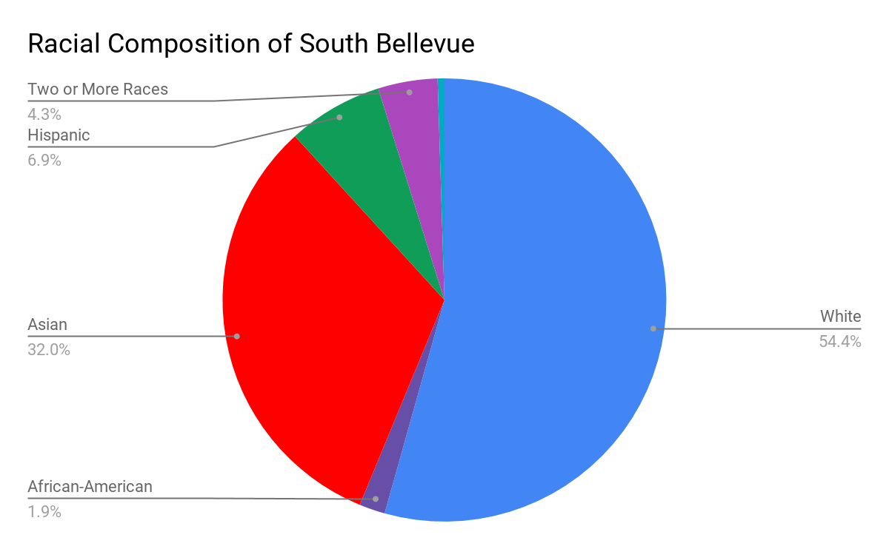

Whites make up a slight majority of the population, representing just over 54% of all residents. However, the area also has a large Asian-American community, representing 32% of the population, as well as sizable groups of Hispanic and mixed-race residents, at a combined 11.2%. Because of the heterogeneous ethnic and racial makeup of South Bellevue it is important to account for equitable distribution of resources and information across every subgroup in South Bellevue. Diversity is one of the main aspects of the South Bellevue community that should be accounted for in the services provided by Mini City Hall.

**Strong Immigrant Communities**

A majority of South Bellevue residents are not from the area. 62.21% of the population were born outside of Washington, including 28.81% who are foreign born. For many people, MCH serves as their first interaction with Bellevue city government or even American government overall. It is important to keep this in mind when designing MCH to create a space that is accommodating and helpful to those who may not be as familiar with the city or its government, a feature that is already emphasized by the existing MCH. It is important to engage the non local and especially foreign born members of the community in city government as their voices are often overshadowed by the more established groups in an area.  Here is a more specific breakdown of the foreign born population in South Bellevue.

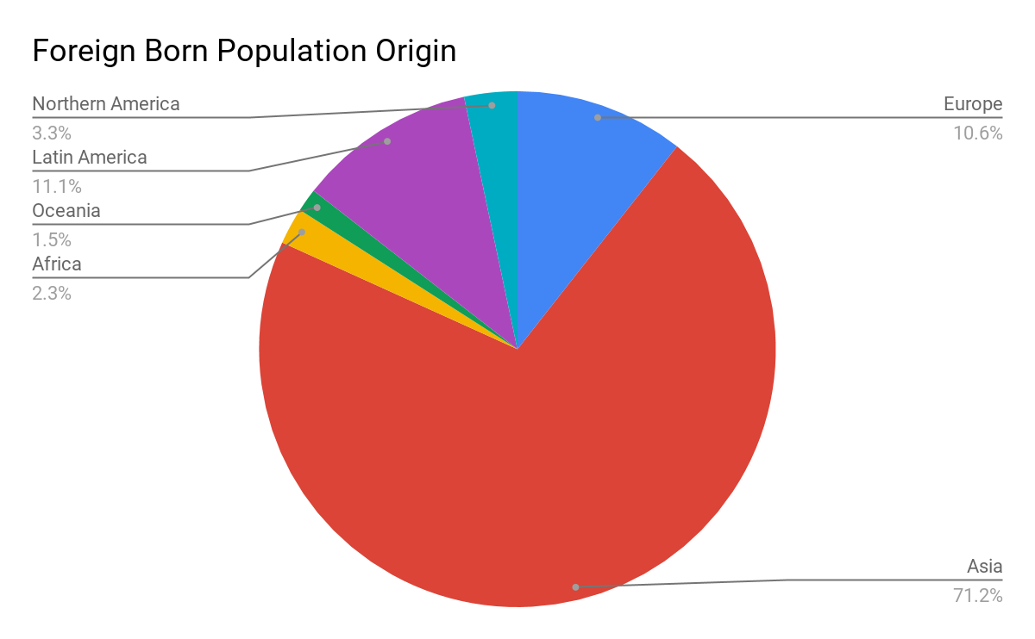

The most significant portion of the foreign born population comes from Asia, with the next largest groups originating from Latin America and Europe. This information is vital to understanding cultural differences among the South Bellevue population that need to be taken into account. The foreign born Asian-American community is a prominent example within South Bellevue, which must be accommodated through steps like targeted information, language specific services, and culturally competent guides from the community in the same mold as the Eastside Cultural Navigator program. This applies to every other foreign born group as well, but understanding the specific demographic breakdown allows us to identify the most effective ways to allocate resources and direct outreach. Offering multilingual services is one step taken by Crossroads MCH that has allowed them to expand the range of residents they can reach. We recommend bringing these efforts to South Bellevue to effectively serve the 33% of residents who speak a language other than English and the 7.8% who speak English less than “very well”.

**High Educational Attainment**

Overall, South Bellevue residents are very highly educated. 61.8% of the population 25 years and older has a bachelor’s degree. This is significantly higher than the national average of 30.3%. Additionally, South Bellevue is home to several highly regarded educational institutions including Newport High School and Bellevue College.  Considering the value placed on education in South Bellevue, MCH should provide services catered toward educational needs. The full educational attainment breakdown of South Bellevue is shown in the chart below:

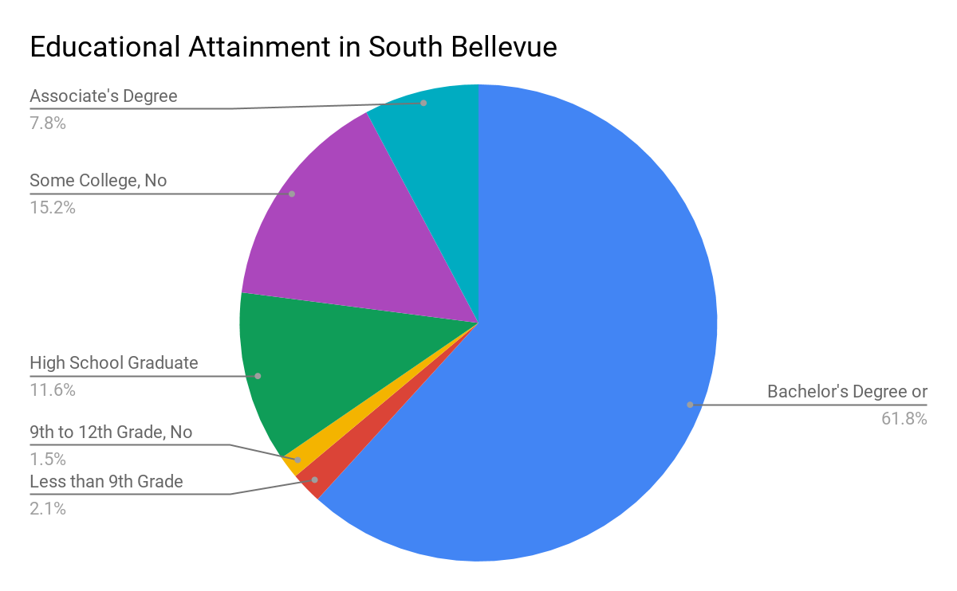

**Economic Prosperity**

One other striking feature of South Bellevue is its overall economic success. South Bellevue contains a plethora of commercial, retail and office development which forms an economic core running along I-90 from Factoria to Eastgate, anchored by the US Headquarters of T-Mobile. Neighborhood commercial centers in Newport Hills, Newcastle, and Lakemont Park act as secondary hubs of economic activity serving subsections of the area.

Household wealth makes up the other key component of South Bellevue’s economic prosperity. A majority (57%) of households make a combined annual income of over $100,000 a year, placing them as solidly middle to upper class. At 22.6%, households making over $200,000 a year represent the second largest income group in South Bellevue. A further indication of household wealth is the high homeownership rate in South Bellevue, at 76.4%. This number is even higher in neighborhoods such as Cougar Mountain, Newport, and Somerset, indicating greater wealth in these subareas.

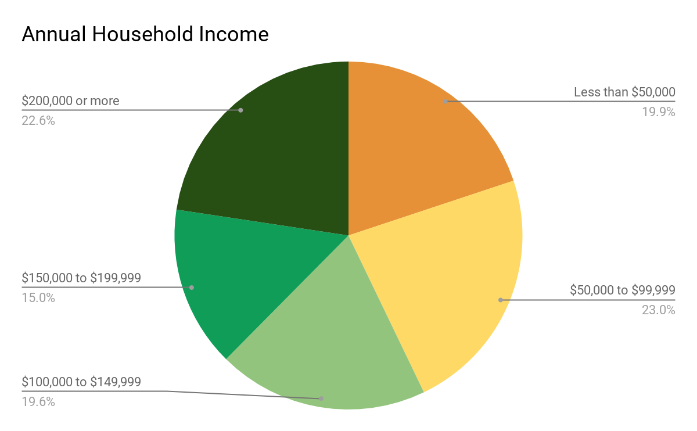

A wealthier class of citizens compared to the Crossroads Area could require a different set of services such as legal information, or permitting and business licensing, both of which registered well on our resident survey. However, wealthier residents also have the resources and connections that may reduce their use of MCH, which could instead be focused on meeting the needs of the many lower income residents in the area and serving as a destination for users outside South Bellevue. For this reason, we considered location sites with greater access to public transportation and major routes and avoided areas that would be more isolated and serve mostly wealthier residents.

**Aging Population**

South Bellevue’s population is aging. The largest group of residents is between the ages of 45-64, representing 32.1% of the total population. This age group is expected to continue aging in place, fundamentally shifting the demographic makeup of the area. While this shift has not been fully realized, it will no doubt alter the activity and needs of the community. MCH must be able to serve people of all ages but will need to take special care to accommodate the elderly and disabled. This includes offering services and information that meet their needs, as well as providing an accessible location. It may be useful to conduct outreach to elder centers in the South Bellevue neighborhoods to best understand the needs of their residents and others in the age range. 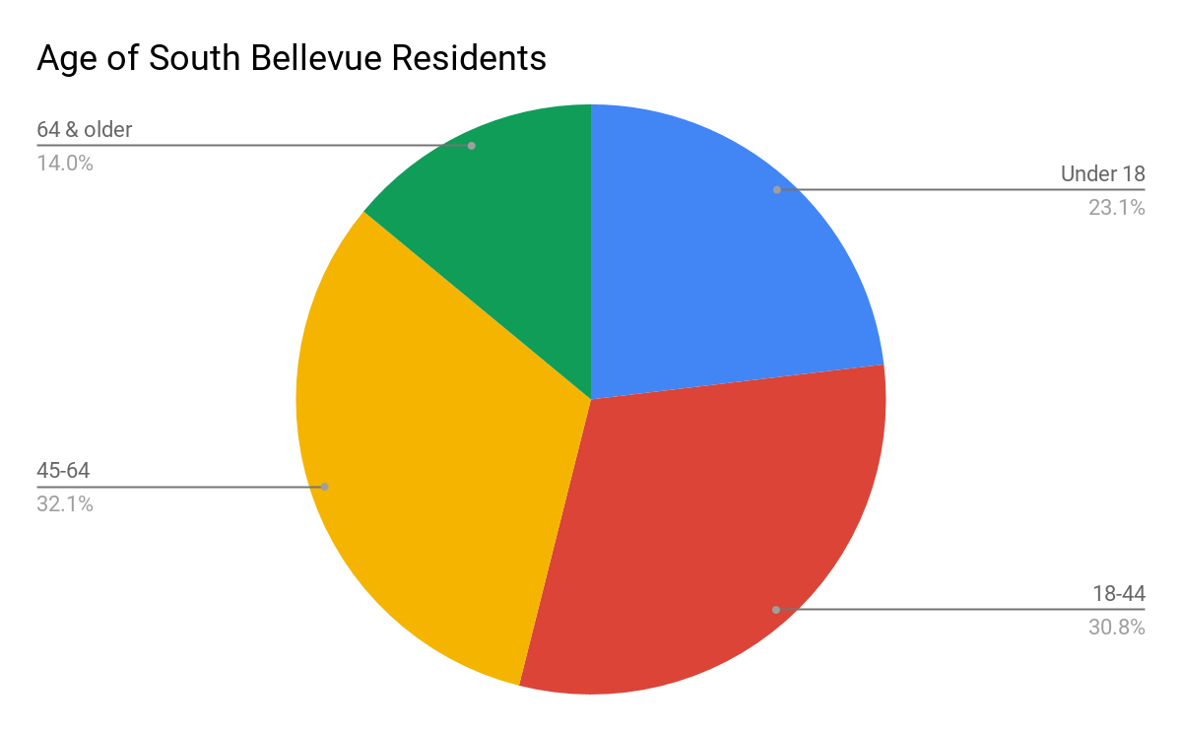

**OUTREACH RESULTS**

**Volunteer/Staff Survey**

A majority of volunteers and staff found out about MCH through a friend or community member that had previously visited MCH, a referral, or by encountering the space while visiting Crossroads Mall. Because of its location in Crossroads Mall, the MCH storefront sees a high daily foot traffic and attracts a number of shoppers that were not originally intending to visit the site. Crossroads Mall’s role as a third place helps MCH gain visibility as people go to the mall for its stores, to hang out, eat food, study, etc.

Prior to discovering MCH, volunteers wanted to be more involved in city government either to gain experience working in city government or to be more involved in their community. Volunteers are the main faces of MCH and run the day-to-day operations. The safe, friendly, and welcoming environment of MCH is created in large part due to volunteers desire to establish a space where anyone is welcomed. This special characteristic of MCH is something that should be carried over to the second MCH when it is established.

The survey also asked staff and volunteers questions about their work experience, transportation methods, demographics. A majority of survey participants live in Bellevue, are ages ranging from lower 40s to 60s and up, and have interests in working at a South Bellevue MCH location. There is a 50-50 split on the question of whether or not staff and volunteers are willing to train new hires. A little over 70% of volunteers and staff are female. About two-thirds of staff and volunteers use their personal motor vehicles when commuting to and from MCH. Commute times were varied, but a common commute time was at or less than 15 minutes. The travel times of 16-30 minute and 31-45 minute commute had equal values while one person listed a commute time between 46 and 59 minutes.

One of the main findings of our interviews with representatives of organizations associated with MCH was their ability to take advantage of the existing location. The reach of MCH goes beyond Crossroads Mall, including the entire city of Bellevue due to its role as a satellite office of the main city hall. Residents are able to access government resources through MCH as well as those offered by its non-profit partners. The location of MCH allows users to access resources offered at Crossroads Mall such as the calendar and transportation information. Seeing the upcoming events enables MCH and non-profit organizations to coordinate their resources and special events towards target audiences. MCH’s location is also a huge asset to itself and its partner organizations. MCH’s location is not only convenient to clients of non-profit organizations but also to those seeking help from MCH.

Based on the survey results and interviews with partner organization representatives, the number one improvement that could be made to the current MCH would be moving to a larger space or creating space for a separate, private meeting room. Volunteers and staff members feel that the current space of MCH is too small for them handle issues surrounding confidential information. The need for a bigger space comes from staff wanting to have more privacy when conducting private meetings with clients instead of at a table a few feet from the MCH’s storefront. Having a bigger space would also give MCH room for more tables and workstations as well as the accommodation of more clients. Other improvements include more partnership opportunities and better employee rest spaces.

Volunteers and staff were asked if they had any recommendations for what should be continued or implemented if a second MCH were built. The number one recommendation made was to have more community partnerships. Volunteers and staff want to continue seeing MCH partner with community organizations that want to serve the Bellevue community. South Bellevue is a community with diverse demographics and the services offered there should be reflective of what the people there want and need. The top categories of partnerships requested by staff and volunteers were education, legal services, and cultural services. Other recommendations include advertisement from the city and materials in different languages

**Results from Volunteer/ Staff survey:** 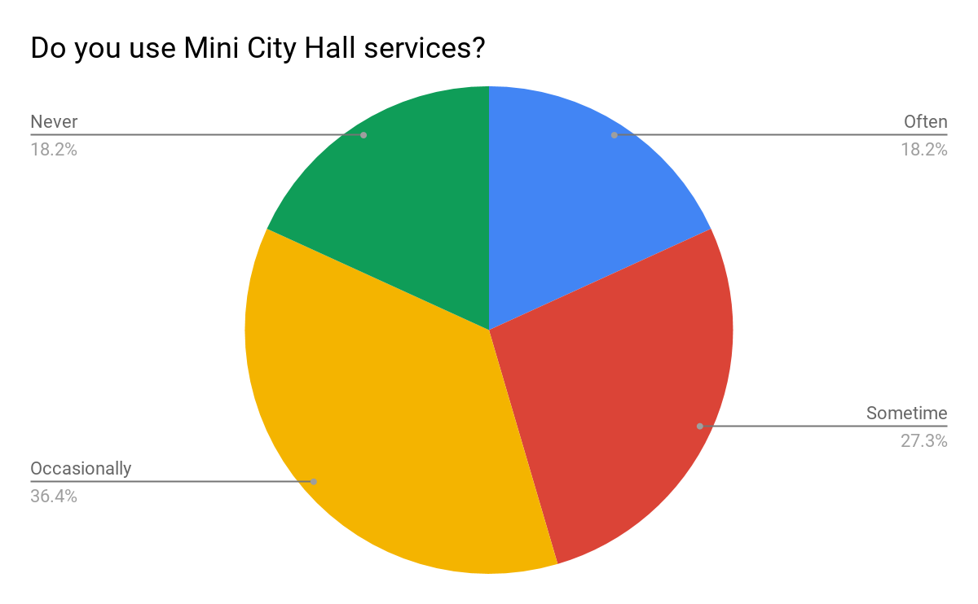

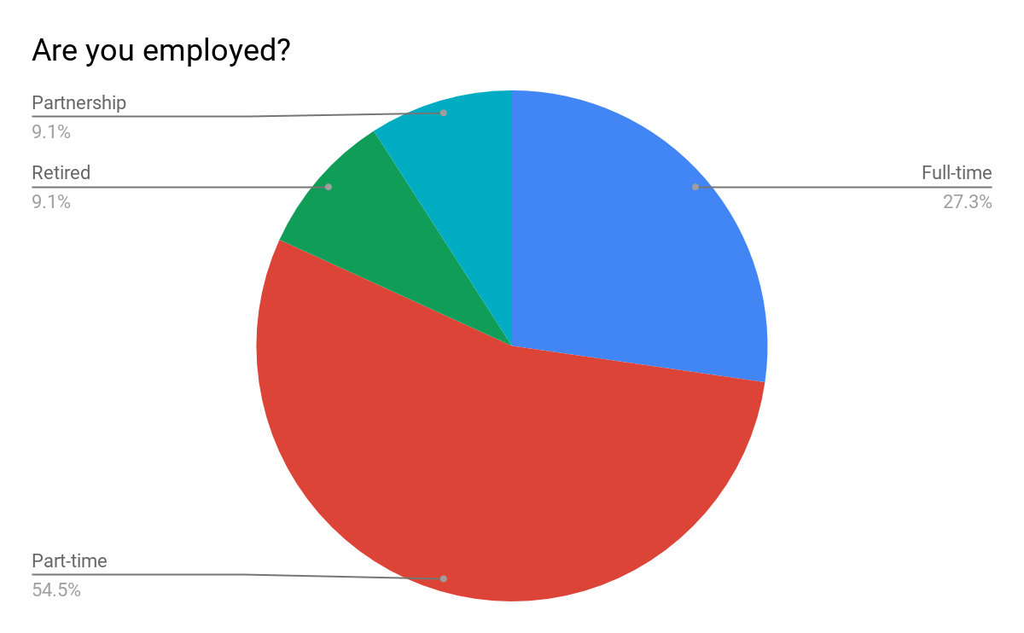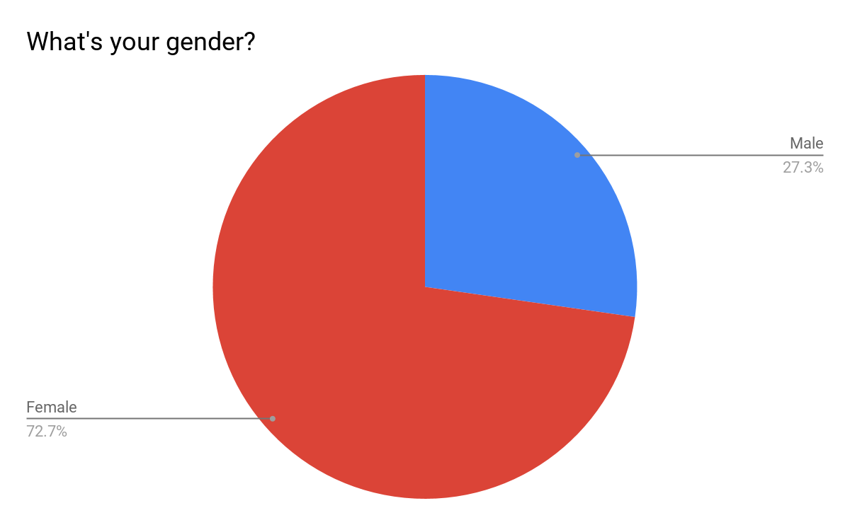

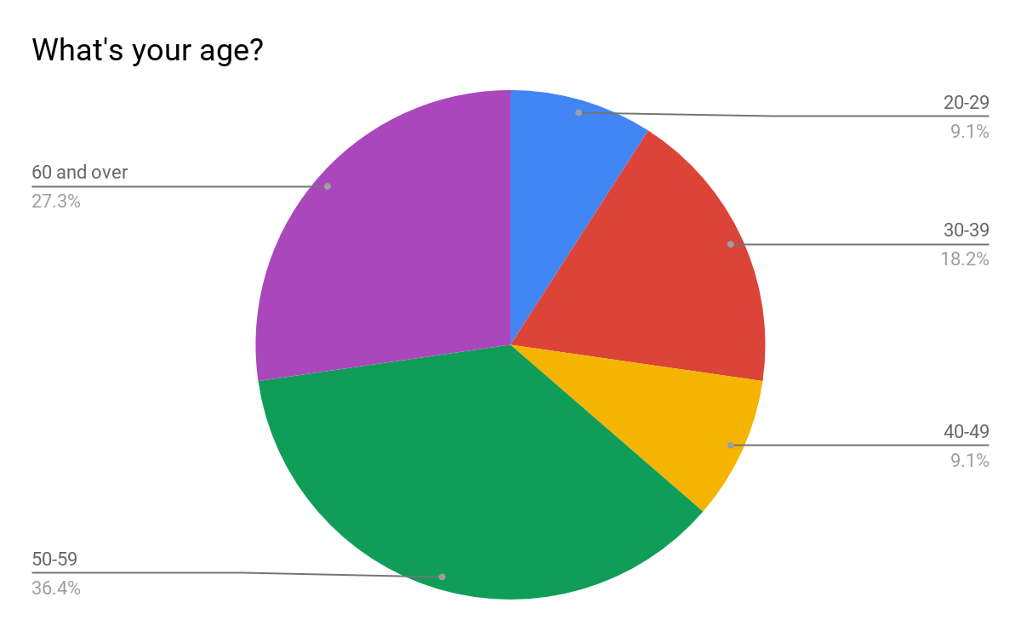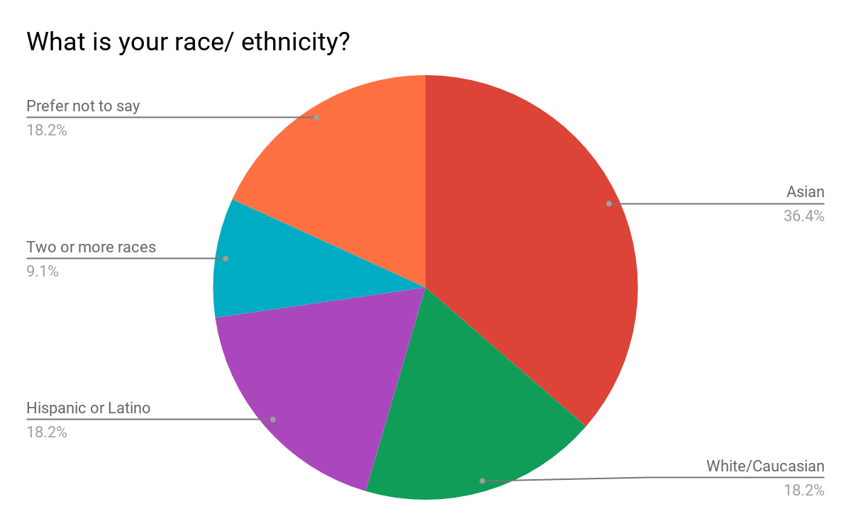

**Mini City Hall Resident Survey**

The Resident Survey received a total of 37 responses. Based on the data we collected from our survey, we found that 60% of participants were already aware of MCH. Of those that had, their main methods of exposure were: their proximity to the existing MCH locating, or having visited or been referred to it before. Chart 11 illustrates data describing how frequent residents would visit a South Bellevue MCH location. Out of 36 responses, 19 participants listed they would occasionally visit the South Bellevue location. Three said they would visit often, five said sometimes, and nine people said they were not likely to visit the South Bellevue MCH. The frequency of residents to visit the newly planned MCH will vary by person, as will the purpose for each visit. However, the location and services offered will play a major part in how often the South Bellevue MCH is utilized and seen.

Referring to the data in Chart 12, parks and recreational opportunities, and the emergency preparedness are the highest requested services, at 70% of all respondents, followed by permits and business licenses at 67%, and neighborhood programs and services at 64%. Based on the top services, we were able to gain a better understanding for the individual and community service needs of South Bellevue residents. The least requested services were refugee and immigration services and translation and interpretation, each garnering a response rate of 16.1%. Those services focus on addressing cultural needs to a smaller target population in South Bellevue which is reflective in the low response rate. Based on our meetings with representatives from partner organization, we came to understand that many people using the services at the existing Mini City Hall reside in South Bellevue. As they are already using the services offered, we believe the existing opportunities and partnerships through Mini City Hall should all be extended to South Bellevue, with the addition of and special emphasis on specific services requested in the survey.

Another key finding from our survey was the great emphasis that residents put on location. A central commercial area might be an ideal option, but it might affect the travel time because of traffic. This was a major concern raised about the Factoria location option, which we had not considered before receiving this feedback on our survey. In addition, many respondents focused on the issue of parking; for example, do we reserve parking specifically for MCH or do we find better ways to utilize transportation services to get people to and from MCH. Parking is one of the top issues that residents are concerned and will play a part in our final recommendations.

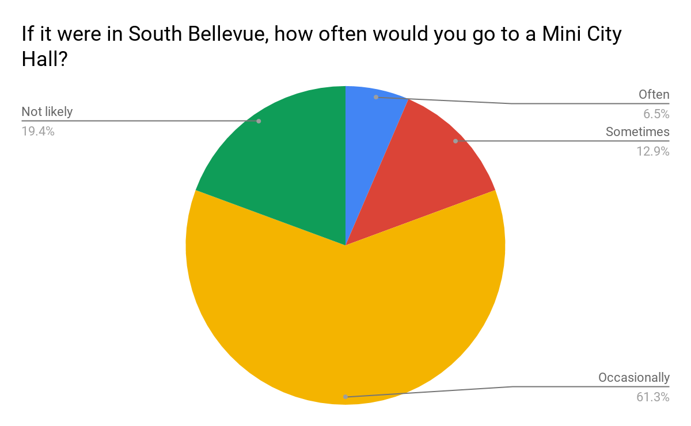

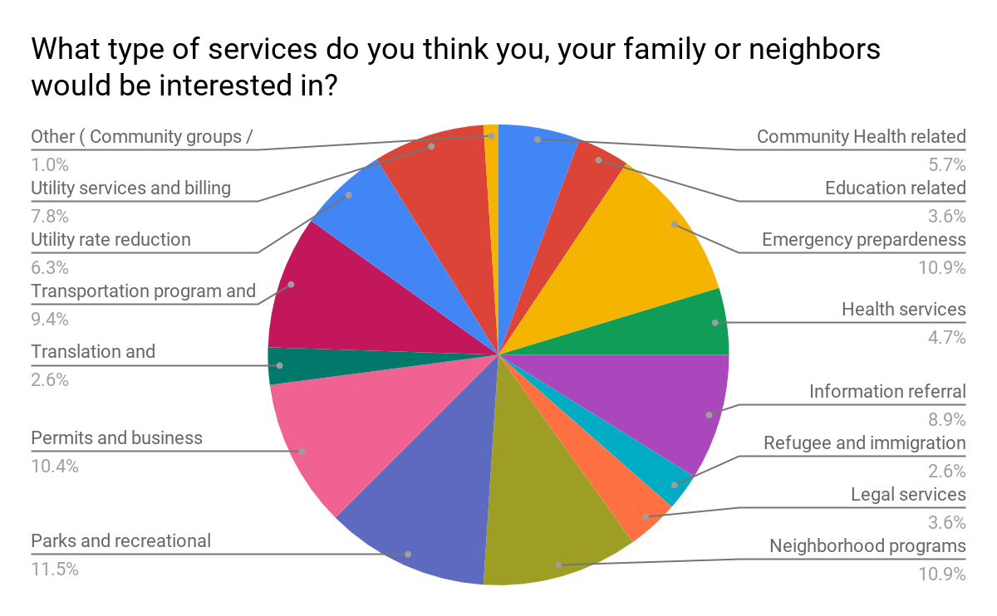

**Lessons from Mini City Hall**

Drawing off our outreach efforts, background research, and case studies, we identified several lessons the current Mini City Hall can offer. A key aspect of the success of MCH is the safe, welcoming environment that a ‘third place’ provides. In a community, there are three social environments that individuals interact with. The home is considered the ‘first place’, and the workplace is referred to as the ‘second place’. In “Going Home: Essays, Articles, and Stories in Honour of the Andersons”, Pete Myers refers to the the third place as somewhere “between and beyond the home and the workplace… [it] provides vital anchors in community life, providing for broader, more creative interaction which is informal but intentional,” (Myers, 37). The current MCH at Crossroads is an important third place for Bellevue residents, catering to both their commercial and community needs. We hope to recommend a location for MCH in South Bellevue that will provide a similarly inviting and hospitable environment.

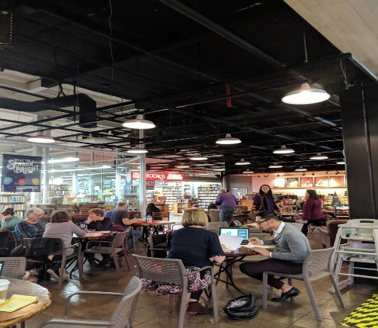 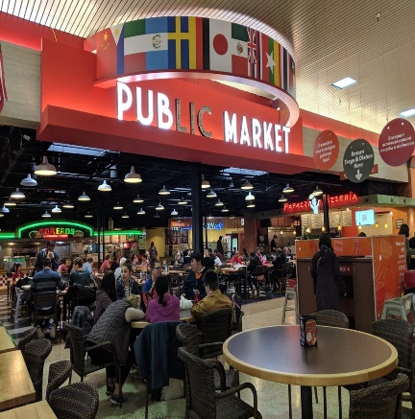

Additionally, based on the responses we received from different meetings and surveys, residents who currently visit MCH at Crossroads enjoy asking questions and receiving suggestions from the volunteers who work there. Residents feel safe and comfortable walking into MCH and asking for help, even if they might need to share some personal information with the volunteers. Residents also like that volunteers consider their point of view, care about the questions asked, and follow cases until they are completely solved. Through our interviews and survey responses, we found that the volunteers from the current MCH at Crossroads are paying their time, effort, and patience to every resident who pays a visit to their location. The volunteer sits one-on-one with the resident and listens to their issues, then provides the proper suggestions, options, or services. During busy seasons such as voting or tax weeks, the waiting time at MCH can be more than 60 minutes. However, people are still likely to wait because they know that workers at MCH are able to help them with their needs. Through this relationship, residents know that they can rely on MCH and the services offered at this location.

In addition to providing quality services, MCH is also located in a quality location. There are many developed facilities surrounding Crossroads Mall, such as grocery stores, restaurants, banks, a post office, parking lot, and public spaces. Due to its busy, central location, Crossroads is highly accessible, with public transportation stops being located nearby and around the mall. The facilities and amenities near and within the current MCH are useful and beneficial, and we would like the new MCH location to replicate the current accessibility and surroundings of the MCH at Crossroads.

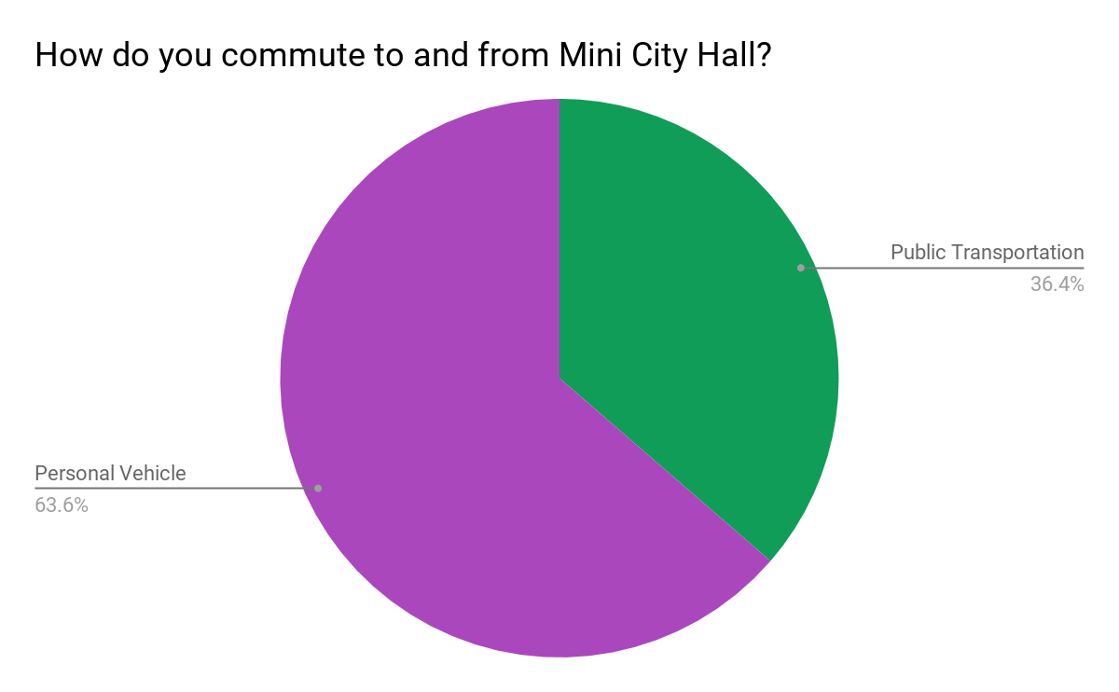

One common issue we found while assessing South Bellevue locations was a lack of parking space. Based on the data we collected, almost 64% of MCH staff drive their personal vehicle to work, while a large majority of visitors utilize the bus system. This means that we would need a location that can cater to both types of commuters. Availability of parking space will another key element to consider when selecting a location for the South Bellevue MCH. Based on the data we received from CoStar, there are a total of 2100 spaces at the parking lots that serve the Crossroad Mall. This works out to 4.83/1000 sq ft. in this area. This amount of parking is able to accommodate the current amount of Mini City Hall users and staff.

**PRELIMINARY LOCATIONS**

**IMPLEMENTATION**

To identify optimal location options for a Mini City Hall in South Bellevue, we began by considering a list of all the possible locations, provided to us by our project lead Mike McCormick Huentelman. We decided not to pursue any other locations as the initial sites we were given seemed to be the only realistic location options due to their placement within the central commercial and service centers of South Bellevue. We also decided to rule out the possibility of a mobile MCH due to the complications with finding several temporary locations, and the benefits of a fixed site in establishing MCH as part of the community and building trust. Here is a map showing all the preliminary locations we considered, with a brief description of each site below.

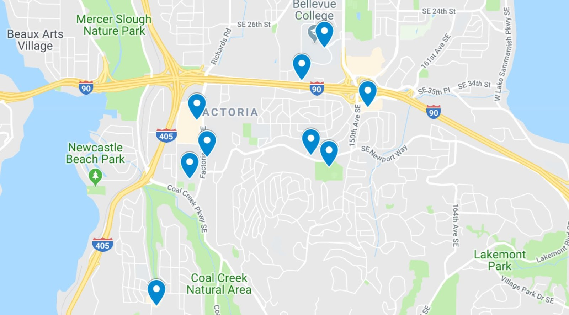

**Eastgate Park and Ride**

**Factoria Mall**

**Bellevue College**

**Eastgate Plaza**

**Newport Hills Shopping Center**

**South Bellevue Community Center**

**Newport Way Library**

**Newport High School**

**Factoria Mall**

Located near the crossroads of I-90 and I-405, Factoria is the commercial and employment center of South Bellevue.  The mall itself hosts a diversity of retail stores while providing services and information to the community. The surrounding area is highly developed with dense retail, office, mixed-use and multifamily residential development.

**Newport High School**

The premiere public secondary education institution in South Bellevue, Newport High School is well regarded for its academic excellence and strong ties to the community through its student body and programs. The site is located just south of the core Factoria neighborhood, at the intersection of Factoria boulevard and Coal Creek parkway. It is proximate to Factoria mall as well as the residential neighborhoods of South Bellevue while providing increased partnership opportunities with the Bellevue School District, especially in regard to educational services.

**Newport Hills Shopping Center**

The core commercial center of the Newport Hills neighborhood, this mid size retail center is highly accessible from locations around the neighborhood and south of the city limits. While in somewhat poor condition, the commercial space at this site offers several options for site specific configurations and is accessible to several community gathering sites including schools, churches, and community centers.

**Bellevue College**

The largest public institution of higher learning in the Eastside, located north of I-90 in the Eastgate area. Highly accessible by public transportation and offers extensive partnership opportunities with the student body, faculty, and additional resources of Bellevue College.

**Eastgate Park and Ride**

Main public transit node in South Bellevue, connecting the area with locations in Downtown Bellevue, Seattle, and the wider region through King County Metro and Sound Transit bus lines. The nearby Eastgate Public Health center would be the best option to host a branch of Mini City Hall and operates many services that could be offered through a partnership with MCH.

**Eastgate Plaza**

Commercial core of the Eastgate neighborhood. A small retail center with spaces available to host a new Mini City Hall. Well positioned to expand service to South East Bellevue and connect the various service locations in the area.

**South Bellevue Community Center**

Located along Newport Way, this site provides unique community engagement opportunities through recreation. The community center already provides many of the functions at a basic level that could be enhanced by hosting Mini City Hall. While the overall accessibility of the site is somewhat low, its central location within South Bellevue and well-maintained facilities make SBCC a strong option for consideration.

**Newport Library**

Just west of South Bellevue Community Center along Newport Way, Newport library has many of the same locational benefits and accessibility concerns. Locating Mini City Hall here could expand the educational opportunities provided through cooperation with the King County library system, a model for success we have seen in both Crossroads Mall and our case study in Southcenter.

**CRITERIA**

To narrow down our location options, we created a matrix to assess each site based on a number of criteria we determined as key to the success of Mini City Hall. This allowed us to evaluate each site individually while also comparing and contrasting them with one another to determine a set of final options. Listed below are the criteria we included in our assessment, with driving questions and short descriptions to explain each in more depth:

■ *Locational Context*- How central is the location within the neighborhood and are there any geographic barriers? Does it take advantage of major transportation or development nodes, circulation paths? What features are located nearby and which are not?

■ *Personal Vehicle Accessibility*- Is this site accessible for drivers? Is there ample, affordable parking and connection to major roads?

■ *Multimodal Transportation Accessibility*- Does the site offer easy access for those not using a motor vehicle? This would include proximity to public transit routes, bike lanes and bike racks, pedestrian access with sidewalks and crosswalks.

■ *Practical Accessibility-* What is the condition of the effective, ground-level accessibility of a location? Concerns over the visibility of a site, accommodations for disabled or elderly users and other related issues.

■ *Age and Condition*- What is the condition of available building facilities and are they maintained properly?

■ *Educational Opportunity*- What are the nearby educational institutions including schools, libraries, colleges, and what educational or training programs are available to the general population?

■ *Commercial Opportunity*- How much retail and office space is nearby? Does this location serve the commercial needs of South Bellevue residents?

■ *Community Gathering*- Does the location act as a third place or community gathering space? Are community resources or assets nearby or readily available?

■ *Partnerships/Programs Available*- What sort of community organizations or institutions have ties to this place or could be connected to it? What programs are currently offered through the site?

■ *Existing Development*- How developed is the surrounding area? What type of development is nearby?

■ *Development Opportunity*- How much potential does the surrounding area have for greater development? Includes plans for upzoning or major new projects, as well as the overall capacity and suitability of the site for expanded development.

■ *Availability of Space-* Does this site realistically have the space available to host Mini City Hall in South Bellevue? Will space be opening up shortly?

■ *General Characte*r- Short description of each site, noting its defining features.

■ *Additional Factors*- Conditions specific to this site that warrant further consideration.

**LOCATION ANALYSIS**

**Option 1: Factoria Mall**

The first location option we have identified is Factoria Mall. The Mall, officially titled Marketplace @ Factoria, is a mid-sized regional mall located in the Factoria neighborhood of South Bellevue. Since opening in 1977, it now houses more than 60 stores along with several large anchor tenants including Target, Old Navy, DSW Shoe Warehouse, and the Nordstrom Rack. The building underwent a major renovation in 1999 and has had regular updates and improvements ever since. The mall has 375,000 square feet of space, with 90.8% of the leasable space being occupied. Factoria not only serves as the commercial center for South Bellevue but also draws customers from all across the Eastside.

**Strengths**

Accessibility: Factoria is widely accessible by several means of transportation. It is located near exits off of both I-405 and I-90 and sits alongside major connecting arterials like Factoria Boulevard and Coal Creek Parkway. The mall itself has over 2,570 parking spaces (5.59/1000 sq. ft), while the surrounding area has many more parking spaces. Several bus lines run through Factoria, providing access to and from other neighborhoods of South Bellevue, Downtown Bellevue, Renton, and Seattle among other locations. The pedestrian infrastructure of the area is also well developed, with wide sidewalks and frequent crosswalks available, with an assessed walk score of 74, indicating very good walkability. There are several pedestrian infrastructure improvement projects scheduled in the area in the near future, detailed in the City’s Comprehensive Transportation Project list. A Mini City Hall located at Factoria would be highly accessible for almost all South Bellevue residents.

Prime Location: Factoria’s location within Bellevue makes it an attractive option for a MCH. The area is situated roughly 4 miles south of Downtown Bellevue, or about a 10-15-minute drive or 30-minute bus ride. It is a 15-20-minute drive from Crossroads mall, enough of a distance to reduce concerns over service provision overlap. As mentioned before, Factoria is near both I-405 and I-90, providing quick access to users from outside the city including Renton, Issaquah, and Seattle. Coal Creek Parkway connects the location to the Newport Hills and Newcastle areas. Factoria is also the closest location to Seattle, which allows for greater partnerships with the many Seattle-based organizations that could work with MCH.

Commercial Development: In addition to its central geographic location, Factoria is the main established commercial center in South Bellevue, based around Factoria Mall. There is a mix of retail and office development in the surrounding area, anchored by the T Mobile US Headquarters, a massive office complex east of Factoria Boulevard. Factoria has a variety of commercial types that serve the broad consumer needs of the entire South Bellevue area. It also serves as the largest employment center in the area, with over 10,000 daytime employees working in the 1-mile radius surrounding the mall. MCH could build of the established development in Factoria to attract a user base among South Bellevue residents who already frequent the area.

**Challenges**

Being a central commercial, employment, and transportation node of South Bellevue lends Factoria Mall several benefits but also brings significant drawbacks. From our resident survey, we understood that many people were wary of Factoria due to the high amount of traffic in the area throughout the day. Factoria Boulevard is a major thoroughfare, linking Coal Creek Parkway to Richards Road and Downtown Bellevue. Exit 10B is directly north of the site, creating additional traffic as cars enter and exit off I-90. The intersection of 128th Ave SE and SE 38th Street near the main entrance to the mall has an Annual Average Daily Traffic (AADT) count of 35,750 (Costar), one of the highest in South Bellevue. This issue could impact the accessibility of a MCH at Factoria, making it much less convenient of a location for residents to get to and use. The car-centric design of the area and high traffic volume also reduces walkability and bike-ability.

While being a major office and retail center, Factoria does not have the same amount of use as a community gathering space or the same partnerships, especially when compared to Crossroads Mall. We identified this aspect of Crossroads to be key in the success of MCH, so its relative absence in Factoria is a major concern. The Bellevue Police Department has a branch located in the Mall, and there is a small kiosk with public transportation information available. However, there is not the same emphasis on community space as in Crossroads. The mall’s layout does not create a central gathering space, nor is there the same amount of easily accessible signage and displays. The area directly surrounding the mall is almost all made up of retail and office development and the only main community institution nearby is Newport High School, which is still a 15-minute walk to the south along busy roads.

**Site Plan**

Our vision for a MCH in Factoria would see the new branch occupying site similar to number 49 within the Marketplace @ Factoria. This site is just off from the central node of the mall, providing easy access from all areas and offering high visibility for potential users. It is close to the main anchor store of Target and the large amount of parking in the back while being easily accessible from the main entrance facing Factoria Boulevard. However, it is distant from the Police station in the mall, which will reduce service coverage overlap and create a more calm, intimate environment.

The site is 904 square feet, significantly larger than the space at Crossroads mall. This will allow for greater capacity and use of the space within MCH itself. There is room for all the amenities currently present in MCH as well as many other including a secondary room for more private discussion. We found the condition of the site roughly comparable to the space at Crossroads Mall. Based on preliminary market research, we estimate an annual rental rate in the range of $38-46 per square foot, indicating a monthly rate for the space between $2,862 and $3,465.

**Nearby Community Assets:** Newport High School, Bellevue Police Department, Bellevue Fire Department, Seattle Humane Society, Factoria Transfer Station, Tyee Middle School and Gym

**Option 2: Eastgate Plaza**

The second main location option we have identified is Eastgate Plaza. Eastgate Plaza is a small retail shopping center located off 150th Ave S and just to the south of I-90. It is at the center of the Eastgate neighborhood of South Bellevue, acting as a third place for the community with major retailers such as Safeway and Rite Aid anchoring a variety of smaller retail shops, services, restaurants and coffee shops, and several gas stations. Eastgate plaza has 74,980 square feet of space (Costar). It also serves as an extension of the commercial and office development directly across I-90 to the north, which connects the area to Bellevue college and the neighborhoods of mid-Bellevue. The area is defined by its office complexes which house many new-economy businesses, including Verizon and T-Mobile

**Strengths**

Accessibility: Eastgate Plaza is easily accessible from both the east and west by I-90 as well as from the North and South by 148th Ave and Newport Way. It is just under 5 miles from City Hall, about a 10-minute drive or 30 minute bus ride, and 3.7 miles from Crossroads Mall, or about a 10 minute drive or 40 minute bus ride. It is served by four bus routes with stops nearby, connecting it to Factoria, Downtown Bellevue, Issaquah, the University of Washington. Eastgate Park and Ride is a 15-minute walk away, a major transit center which services several additional bus routes connecting the area to places throughout Bellevue and the overall region. The Eastgate Plaza property scores at a 50 for both *walkscore* and *transitscore*, indicating moderate success in both of these aspects of accessibility. The Mountain to Sound Greenbelt trail is a major pedestrian and cycling thoroughfare that passes near the site and is scheduled for improvements which will surely increase its use.

Coverage: Eastgate’s location makes it conveniently accessible for residents of more distant South Bellevue neighborhoods such as Cougar Hills, Hilltop, and Somerset. It can also better serve neighborhoods in Mid-Bellevue that are not nearby Downtown or Crossroads, including West Lake Sammamish and Robinswood.  In terms of expanding service to most underserved areas of Bellevue, Eastlake is the best location option. An Eastgate location would be perfectly placed to bring together South Bellevue Community Center, Newport Way Library, Eastgate Public Health Center, and community organizations to create a robust service cluster in an area where this does not exist.

Development Potential: While Eastgate plaza is an established commercial center in South Bellevue it is not as built up as Factoria and has greater potential for future development. Placing Mini City Hall in Eastgate allows the City to best serve and collaborate with the community as the area develops. The City of Bellevue Comprehensive Plan projects an additional 900 units of housing as well as 8,100 new jobs in Eastgate by 2035. The City has designated Eastgate a a mixed-use center, hoping to encourage a large amount of this type of development in the area. Furthermore, as a secondary hub, Eastgate is far less busy during all times of the day than Factoria. This is evidenced by the Average Annual Daily Traffic (AADT) of 27,990 at the main intersection of 150th Ave SE and SE 38th Street (Costar), meaning almost 8,000 fewer vehicles pass through the area on a given day than Factoria. It could have greater actual accessibility than Factoria which could make it more convenient and effective as a service provider and destination.

**Challenges**

Eastgate Plaza is a much less developed area, which presents issues in terms of usability and effectiveness. The area does not have the same established user base and thus a MCH located in the area may struggle connecting with the largest number of residents. The area was only annexed in 2012 and its role within the city is not as defined as the other main option areas. Furthermore, Eastgate Plaza itself is a purely commercial location that lacks any sort of greater community gathering capacity. While service providers such as Bellevue College, Eastgate Public Health Center, Newport Way Library, and South Bellevue Community Center exist in the same general area as Eastgate Plaza, they are relatively isolated individually, which may make integrated partnerships difficult. The proximate area around Eastgate Plaza is a service desert, which would make a MCH there relatively isolated as well.

Contributing to this isolation and scattering of services is the major physical barrier posed by I-90. This obstacle separates Eastgate Plaza from the commercial and office development along SE Eastgate Way, just to the north of the freeway. While Bellevue College is only about half a mile from Eastgate Plaza, the walking time is more than 15 minutes and requires travelling alongside busy roads and crossing over I-90. The closest pedestrian crossing linking north and south of the freeway is difficult to find, and winds through several isolated areas that may pose safety concerns for users, especially during nighttime. Walkability is a major need for any MCH location, and it is severely hindered by the presence of I-90 near Eastgate Plaza. More importantly, I-90 limits the site’s engagement with development and services to the north of the freeway.

**Site Plan**

We have located 2 available spaces on the western side of the main Eastgate Plaza building. They are both roughly 840 sq. ft, just over twice as large as the Crossroads MCH site. Both are externally facing and easily visible, with their main entrances opening to the walkway that wraps around the entire Eastgate Plaza development. There are several parking stalls as well as disabled parking available just outside the entrance of each spaces, in addition to the 328 surface spaces (CoStar) available for the entire shopping plaza, or 4.28 spaces for every 1000 sq ft. The building was constructed in 1956 and underwent its last major renovation in 1986. The spaces themselves are in fair quality but are less optimal than those offered at the other two final location options. We project an annual rental rate of $39 to $48 per square foot, indicating a monthly rate for each available space between $2,730 and $3,360.

**Nearby Community Assets:** Newport Way Library, South Bellevue Community Center, Washington State DMV, Eastgate Elementary School, Eastgate Public Health Center*, Eastgate Park and Ride*, Bellevue College*

**Option 3: Bellevue College**

The third location option we have identified is Bellevue College. Bellevue College is the 3rd largest institution of higher learning in Washington, with over 32,000 students enrolled annually. The school is located near one of the potential sites we have identified for further study, Eastgate Plaza. However, it is far enough (a mile by walking) for us to give it separate consideration. Just like Eastgate plaza, it is accessible from the west and east by Interstate 90 and from the north and south by 148th ave SE. In December 2019 a new building, the Student Success building, will open. This could be a great opportunity for the City of Bellevue to partner with Bellevue College to potentially locate a new MCH in either the new building or the existing space.

**Strengths**

Transit Accessibility: Bellevue College is directly accessible via transit with 4 King County Metro (Metro) bus lines running through the campus. In addition, Eastgate Transit Center, linked by a pedestrian path to the campus, offers access to 15 bus lines (12 for Metro, 3 for Sound Transit) that connect the area to places around Bellevue and the greater region. The park-and-ride also provides an additional 1614 stalls of parking.

Collaborative Potential: Locating a new Mini City Hall Bellevue College’s campus opens up a world of collaborative possibilities with Bellevue College’s resources, programs, staff and students. Students could volunteer or work at MCH, providing their effort and expertise. Various programs ranging from interior design to healthcare, language study, and sociology could also use the site as an ongoing learning opportunity, developing the skills of their students while handing the operations and service provision of the site to meet the needs of the community. The educational opportunities open to MCH users is also much greater at this site, where they can be connected directly to the programs and resources offered by the College.

Updated Facilities: By placing MCH in the new Student Success Center, it can take advantage of the benefits of the new, state-of the art facility. Compared to the other two final location options, the site in which MCH will be located will have much better amenities and serve as a more inviting space for staff and users alike.

**Challenges**

Bellevue College’s somewhat closed campus may be seen as unwelcoming, especially to people who have no connections to the institution. It may be difficult for non-English speakers to navigate through the campus to find MCH The college does have numerous connections off campus and makes a strong effort to present itself as welcoming to outside visitors. The overall diversity of the student body and staff will also serve to help accommodate or connect visitors from a diverse range of backgrounds.

Parking availability is a major concern for this site. On campus parking fills up quickly and much of it is reserved for student and staff. The nearby Eastgate park-and-ride is normally at capacity after 9 AM. An additional source of visitors like MCH would put additional strain on the already difficult parking situation on and around the campus. This issue could severely limit car access to the site that many residents in the more suburban parts of South Bellevue depend on.

Bellevue College is the closest site to the existing MCH at a distance of about 2.7 miles, an 8-minute drive or 30 minute bus ride. Service overlap may be more of an issue here due to this relative proximity and coverage would not be expanded to as many new areas of Bellevue. However, the services provided at this location might be distinct enough from those offered at Crossroads MCH that this issue will be diminished.

**Site Plan**

We were not able to obtain information on the site specifics of a Bellevue College MCH. We spoke with a representative from the College who offered the possibility of locating MCH in the new Student Success Center, which is set for completion in 2020. There are several vacant houses on campus that are currently available to be used as sites for a potential location. We do not have information regarding the size, layout, or potential cost of either site options, details that would need to be ironed out between the city and college.

**Nearby Community Assets:** Eastgate Public Health Center, Eastgate Park and Ride, Bellevue College, Seattle Family Discovery Center

**FINAL RECOMMENDATIONS**

**FINAL RECOMMENDATION**

**Location**

We recommend Option 1 at Factoria Mall as the best location for a new Mini City Hall in South Bellevue because it can take advantage of the existing user base in the Factoria Mall. As mentioned before, Factoria Mall acts as community gathering space (3rd place) that attracts people from not only South Bellevue but from the wider region as well with easy access to I-90 and I-405. Factoria Mall is located in the Factoria neighborhood which serves as the primary commercial and activity center in South Bellevue. Thus, the location is able to draw in the large volume of people that go to the area for work, shopping, school and leisure. The area is already highly accessible by several modes of transportation.

Factoria Mall offers several spaces that could host MCH. The site could function similar to the existing Crossroads location, with its entrance open to the main corridor of the mall. The space could contain a front desk and informational display, with enough space in the back for an additional meeting room for private discussions with customers. The front area would be left with enough space to have an expanded secondary desk for informational and referral materials or a second meeting table. The meeting capacity of the site could be expanded out into the main corridor of the mall, similar to the way Crossroads MCH uses the space. The increased size of the site would offer greater flexibility in the setup, but cues taken from the effective layout of the existing MCH.

**Services**

Drawing from the results of our outreach and analysis portions, we have determined a set of recommendations for the services offered at a South Bellevue Mini City Hall location. We recommend the continuation and expansion of all of the existing work of Mini City Hall, which already serves many South Bellevue residents. We especially encourage the expansion of the multilingual service and continued partnership with the Eastside Cultural Navigator Program, basing the languages offered on the specific linguistic makeup and needs of the South Bellevue area. We would also like to propose the idea of a full time position the city could hire to rotate between both Mini City Hall locations and City Hall to offer more in depth consultation and referral services to support the efforts of the nonprofit partner organizations.

Important services that could be expanded include legal referral services, provided by organizations such as the International Health Community Services (ICHS) and the Eastside Legal Assistance Programs (ELAP). Mini City Hall already works with the ICHS in this regard, but the increased demand for this service calls for greater emphasis. ELAP is a nonprofit that works to aid people with legal assistance who cannot afford the burden of the high costs of legal assistance. Furthermore, ELAP aids low income victims of domestic violence. In total, ELAP has dedicated over 20,000 hours of service to over 50,000 clients all through the help of volunteer attorneys.

Another important service that a South Bellevue MCH could expand upon is utility rate reduction, continuing the process of having a utility bill dropbox while having more resources available for questions regarding rates and payment. Offering referrals to bill-payment assistance programs and providing information on payment methods and bill reduction techniques could be steps taken towards addressing this concern.

We also recommend the expansion of permitting services offered at the South Bellevue Mini City Hall. Currently there is a permit center in the main city hall, but none at the crossroads location. A miniature permit center could provide services such as: permit history of a parcel, permit applications, help completing permits, public utility locations, code requirements, and environmental maps and regulations.

Overall, Mini City Hall should have an emphasis on South Bellevue neighborhood specific programs and services. By providing information on the events and programs offered throughout the neighborhood, Mini City Hall can improve Factoria Mall’s ability to work as a third place, a factor it lacks when compared to Crossroads.

**Partnerships**

The existing partners of Mini City Hall should all be extended to the new location. From our discussions with representatives from these organizations and our survey for MCH staff and volunteers, the programs they offer are extremely well received by LCH patrons, many of whom come from South Bellevue. The full list of organizations is shown below:

1. Eastside Cultural Navigator Program, through Chinese Information and Service Center
2. Statewide Health Insurance Benefits Advisors
3. King County Library System, working with the Newport Way branch to coordinate specific services
4. King County Public Health, working with the Eastside Public Health Center to coordinate specific services
5. International Community Health Services
6. King County Metro, incorporating the public transportation information display currently present in Factoria Mall
7. Hopelink Diverse Food Program
8. Overlake Hospital Spanish CPR Program

Due to the wide array of educational opportunities available in South Bellevue, we recommend partnering with the educational institutions of the area to provide information on classes, tutoring, vocational training and other programs they offer for people of all ages. Potential targets include Bellevue School District through Newport High School as well as Bellevue College. The South Bellevue location could also work with students from the area to help plan out the site before it opens or work as volunteers to help run operations once it comes online.

To further address the desire for emergency preparedness services through MCH, we encourage partnering with the Bellevue Police Department and Bellevue Fire Department, which each have locations near the proposed Factoria MCH site. They could provide informational resources on safety and emergency preparedness, offer emergency kits, or even conduct emergency trainings through MCH.

Finally, to provide recreational opportunities, MCH should considering working with the South Bellevue Community Center, Coal Creek YMCA, and Bellevue Parks Department. These organizations offer youth camps, exercise classes, and other programs through their facilities to encourage physical activity, recreation and leisure.

While the services they offer were not deemed as necessary by our study, we would like to present the nearby Seattle Humane Society and Factoria Transfer Station as potential partners to consider for MCH.

**Considerations**

The main disadvantage of the Factoria Mall option is the overall amount of street traffic that threatens the accessibility and ease of using the site. If the city wants to avoid these traffic concerns, which are expected to worsen as Bellevue continues to grow, it should consider option 2 of Eastgate Plaza. This site offers many of the same benefits as Factoria without the high usage rate and resulting traffic problems. It is situated in an area with tremendous development potential and a Mini City Hall location here could help coordinate efforts between the several service providers in the area such as South Bellevue Community Center, Newport Way Library, and Eastgate Public Health Center. However, this site currently serves far fewer South Bellevue residents than Factoria and does not act as a community gathering space whatsoever. It has lower pedestrian accessibility and suffers from the barrier to movement presented by I-90.

Bellevue College is the most unique location option due to the possibilities presented by cooperating with the college, especially in terms of educational opportunities. It would be a key step towards strengthening the city’s relationship with Bellevue College and provides the newest, most optimal facilities of the three options. However, its proximity to the existing MCH location and relative isolation from South Bellevue are distinct challenges. This option is also much less defined than the others. To proceed with this location option, the City would need to coordinate several key features of new MCH with Bellevue College, including the services it would provide, the nature of the partnership with the college, and specific spatial setup of the MCH site. This option would take the longest to plan before beginning operations and would likely be more distinct in regard to the existing MCH than the other options presented.

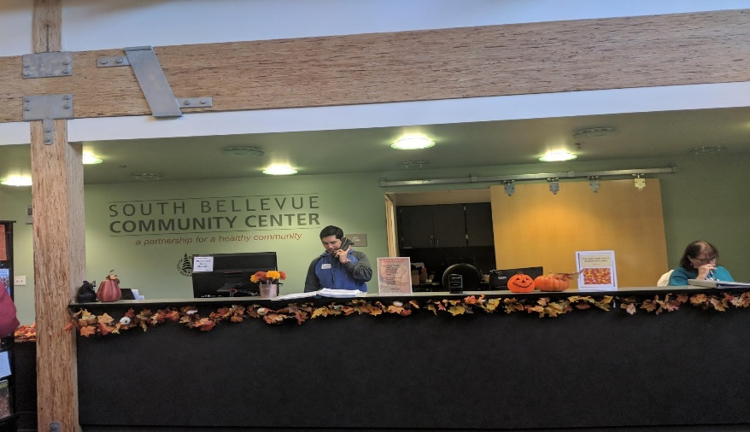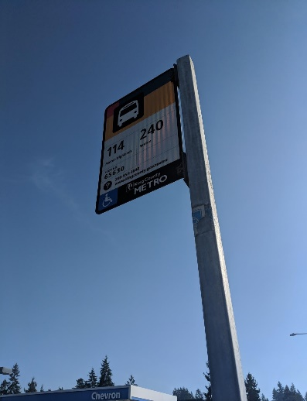

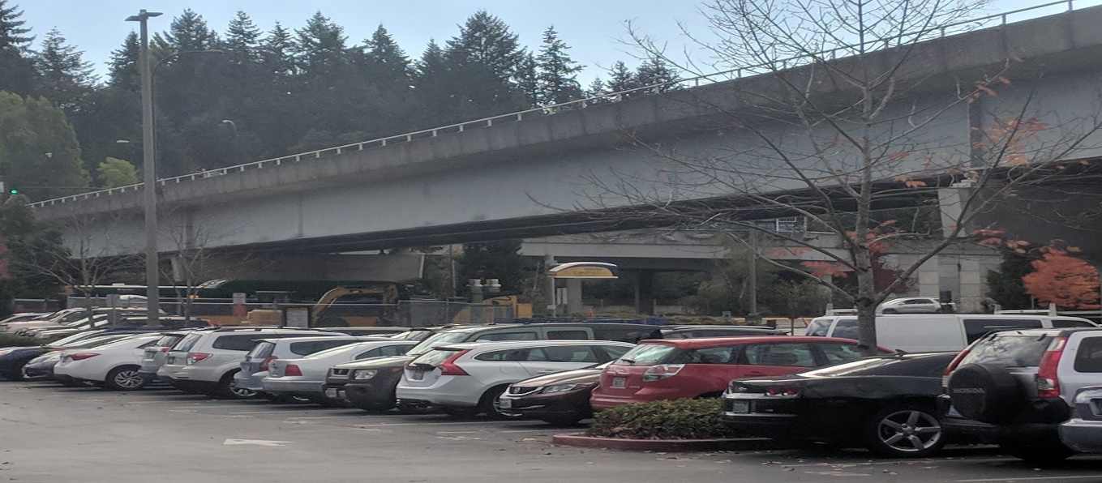

Photos taken on our site visits

**CONCLUSION**

**CONCLUSION**

The goal of this project is to determine where a second Mini City Hall location in South Bellevue should be placed and what services and partnerships should be offered to best serve the residents in South Bellevue. We formulated a methodology that broke our project into three main sections: analysis, implementation, and recommendation

We began by conducting background research into Mini City Hall, relevant Case Studies, and South Bellevue Demographics. This allowed us to determine a set of best practices and lessons to take from existing efforts while better understanding the needs of the South Bellevue community. We then engaged in public outreach by through two surveys, one focused on the volunteers and staff who work in the Crossroads Mini City Hall and the other focused on the residents who live in South Bellevue. We expanded our outreach efforts by meeting with community stakeholders who were familiar with the South Bellevue neighborhood as well as representatives of Mini City Hall partner organizations.

Our analysis led us to create a set of criteria we used to evaluate the preliminary location options for a South Bellevue Mini City Hall. We found that the best way to truly assess our site locations was through site visits to the proposed locations ourselves. This gave our team the opportunity to experience and observe the area first-hand. We narrowed the set of location options down to a final three, offering more detail on the strengths, challenges, and site specifics of each proposed location.

Lastly, we used all this information and referred to our matrix to come up with the final decision of our ideal location. Based on our research, we identified Factoria Mall as the best option for the second Mini City Hall and offered potential services and partnerships to make a location there as effective as possible. We hope that the City of Bellevue will take our suggestions into consideration, and that they use this information as a tool in their cooperative proposal for the South Bellevue Mini City Hall.

Works Cited

City of Philadelphia. "City of Philadelphia Department of Revenue." Philadelphia, City of Philadelphia. https://www.phila.gov/departments/department-of-revenue/about/contact-us/

Coral Springs Parks and Recreation. "Coral Springs Park and Recreation." CoralSprings. City Hall in the Mall. Trustwave. <https://www.coralsprings.org/Home/Components/FacilityDirectory/FacilityDirectory/108/4970>

Coral Springs Parks and Recreation. "Coral Springs Park and Recreation." CoralSprings. City Hall in the Mall. Trustwave.

CoStar Group, www.costar.com

Myers, Pete. Going Home: Essays, Articles, and Stories in Honour of the Andersons. London:

OAK HILL COLLEGE, 2012. 22 11 2018.

Westfield Southcenter. "King County Library System." Westfield. KCLS Library Connection at Westfield Southcenter. https://www.westfield.com/southcenter/stores/all-stores/kcls-library-connection/22985

**Appendix**

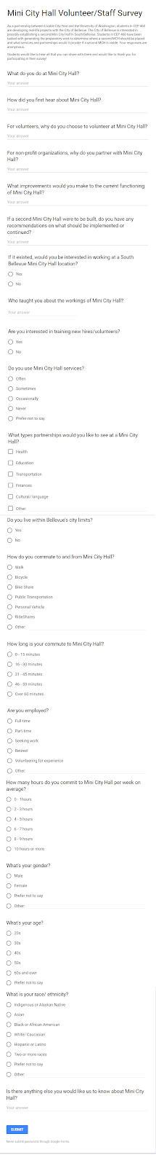

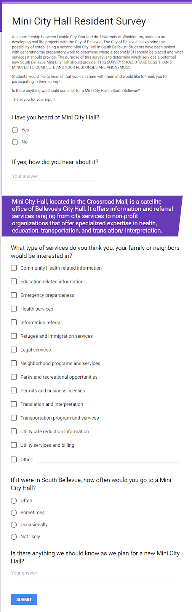

**Location Matrix**



**Community Gathering Spaces in South Bellevue**

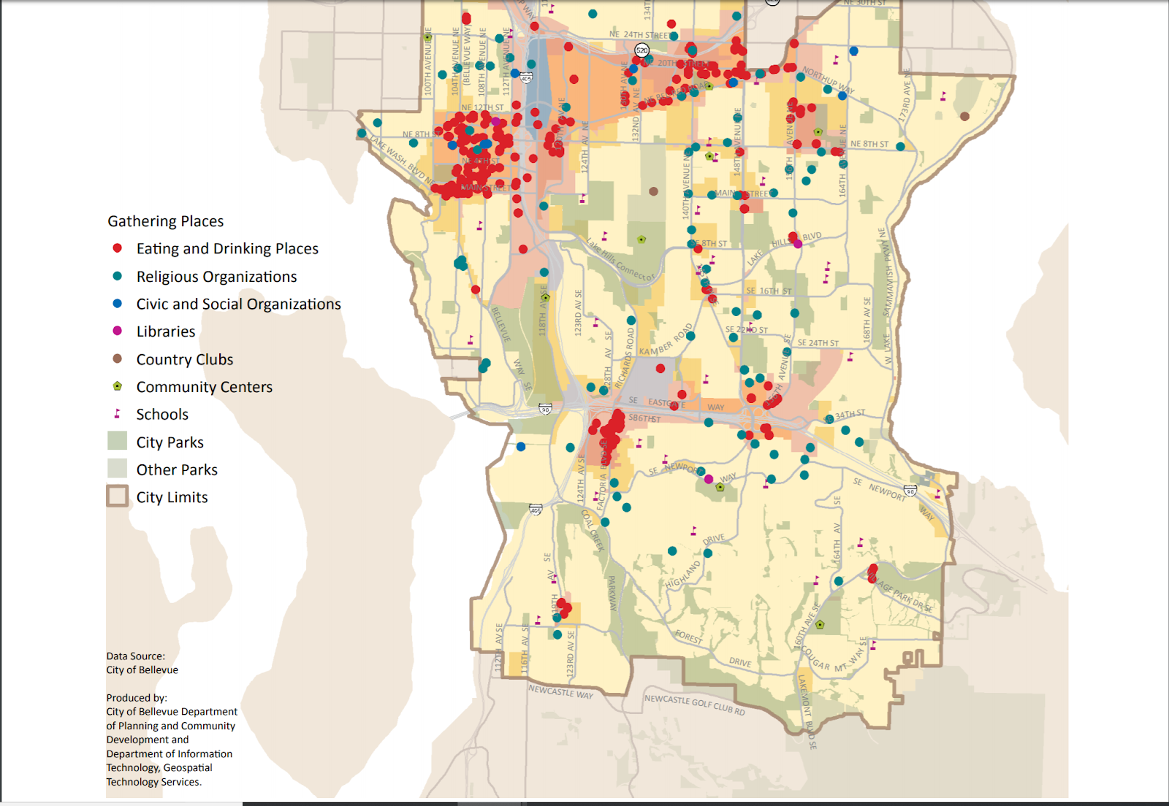

**Sites that were not considered in our final recommendations**

**South Bellevue Community Center**

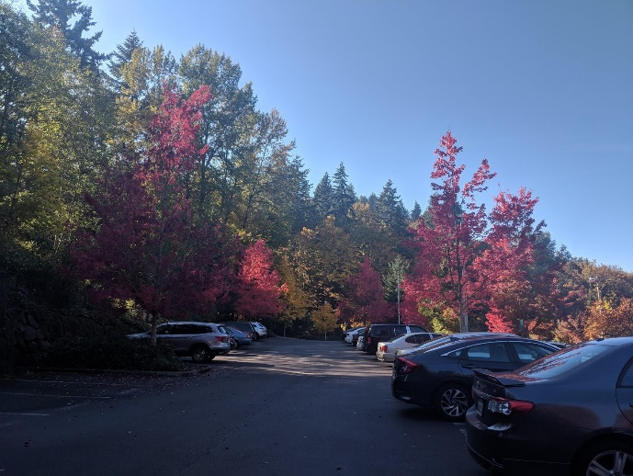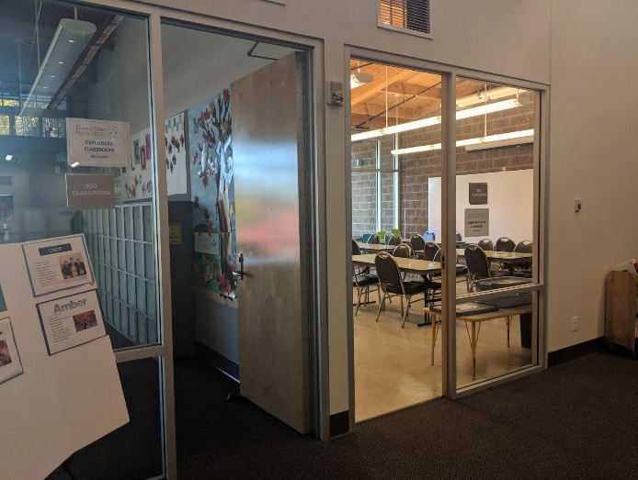

* LCY Student Team

South Bellevue Community Center (SBCC) stood out to all of us because of how well it functioned as a third place and how well maintained the building was. SBCC was partnered with the YMCA to provide recreational facilities for the residents of South Bellevue. The building offered spaces for company meetings and city sponsored events that weren't only for recreation. In addition, the facility housed an outdoor ropes course. Some of the initial concerns of the site included it’s accessibility and visibility. The site is a 9 minute walk from the nearest bus stop and has no sidewalk access to that bus stop. Furthermore, the site is not visible from the nearest public road (Newport Way). It is steep walk once you get off the Newport Way, making it impossible for anyone with disabilities to access the site without a vehicle. Ultimately however, the deciding factor that allowed us to discontinue the evaluation of the site was that there were no space for a MCH in the facility.

**Newport Library**

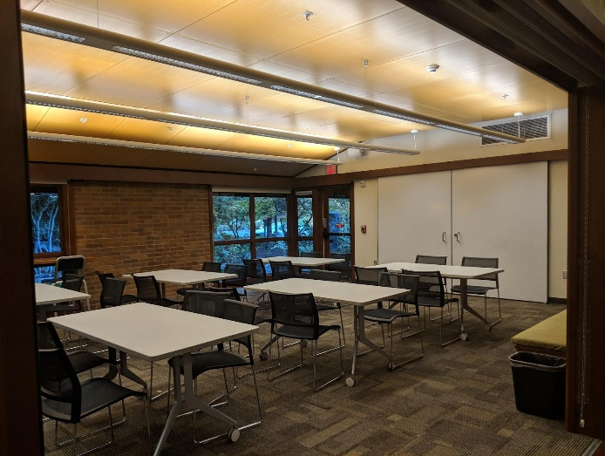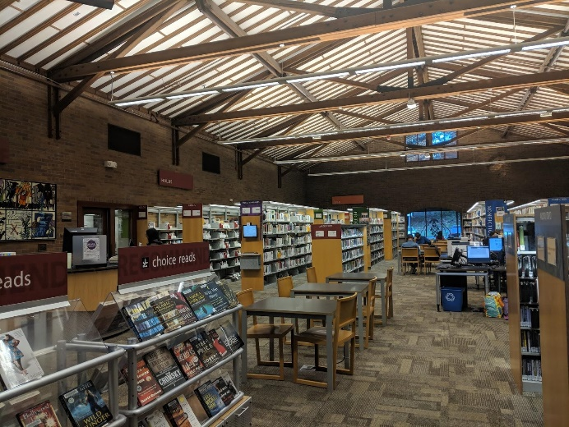

* LCY Student Team

The Newport Library is a short distance from the SBCC. Our group viewed the Newport Library in positive light, with it being a very welcoming place with friendly staff. Programs  in there were aimed towards children, adult technology and English learners. However just like the SBCC, the Library has scant bus service and no direct sidewalk a from the library to the bus stop. The deciding factor in not pursuing this option was that the Library could not host a MCH because there was no space available.

**Newport Hills Shopping Center**

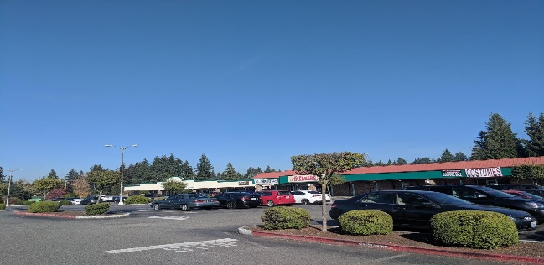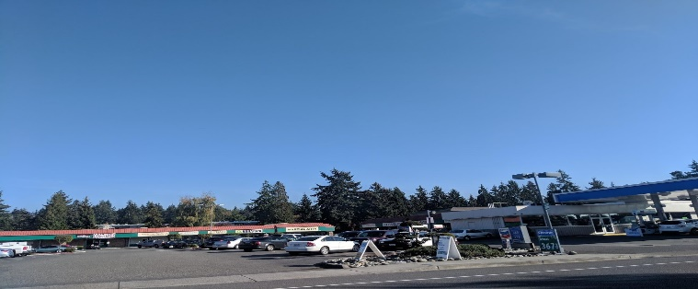

* LCY Student Team

The Newport Hills shopping center was not considered for further evaluation because of several reasons. For one, the location of the shopping center is situated on the southern fringe of South Bellevue, with no major centers of activity that a MCH could draw a user base from. We envisioned a partnership between the Newport Hills Community Club and a potential MCH in the Newport Hills shopping center. However we were told by Ying Carlson that the NHCC was primarily a club for residents of the neighborhood and not South Bellevue as a whole. Second, the condition of the plaza was in need of a facelift or remodel. The parking lot was in need of repair, and a lot of it was not being used. The buildings were also in need of remodeling.  Finally, we were unable to find any space that MCH could use in the plaza.

**Newport High School**

Newport High School was removed for further consideration because our group felt that it may not have been the most appropriate environment for certain services that require privacy. Students may not feel comfortable with their parents or family using MCH in front of their peers because of the reputation MCH has in serving underserved and underrepresented groups. Furthermore, after reaching out to staff at Newport High School it was confirmed that there was no space for a MCH.

**Eastgate Park and Ride**

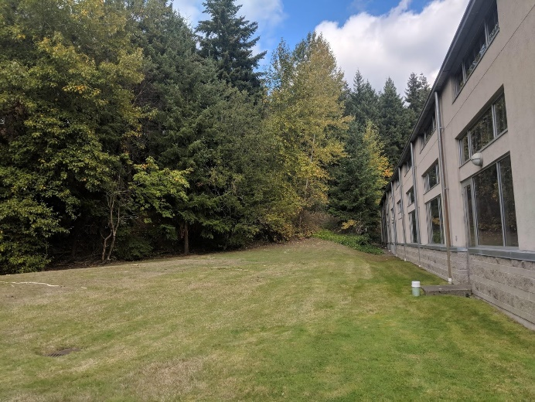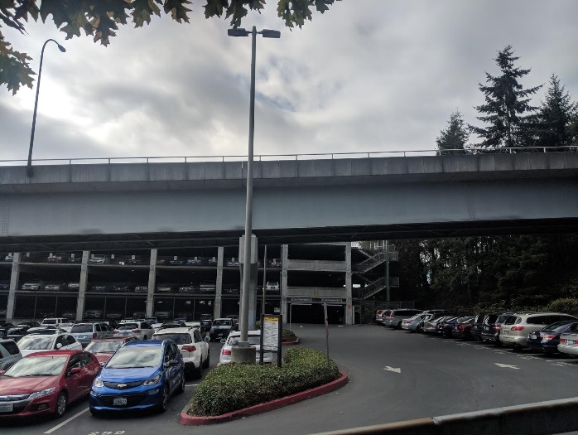

* LCY Student Team

Eastgate Park and Ride was not considered for further evaluation because the area did not functioned as third place. People only use the facility for access to the numerous bus lines that serve the area. There are plans to build light rail in the area, but that will not be built until 2040.