Seattle’s Urban Villages: In Theory and Practice

Introduction:
One of the most influential ideas to have emerged within the planning world over the past several decades is the concept of neighborhood planning. This set of ideas has transformed the urban planning process, providing a whole new methodology with which planners propose and implement their plans, emphasizing a much greater degree of public involvement. In Seattle, this trend can be seen with the shift toward urban villages, first put into practice in the 1994 Comprehensive plan. In this report, I will first define the concept of the urban village and describe its relation to neighborhood planning. I will then review the history of the urban village as it has been applied in Seattle, using the case study of the International District. I will examine implementation history and the current day effect of this planning technique to draw conclusions about the degree of success it was able to achieve and which did not, hopefully allowing for a greater understanding of the value of the urban village concept and neighborhood planning as a whole.
Issue/Context:
First, we must define what exactly an urban village is. Upon first glance, the term seems like a contradiction. It is often thrown around as a buzzword to evoke an idealized sense of community, combining the positive features of its two component parts into a cohesive whole. Urban villages have the activity, livability and sustainability of urban life while maintaining the safety and intimacy of a village. David Sucher points out the fundamental contradiction in these two ideas, explaining: “The Urban Village concept, at its heart, is a fragment of poetry… a way of describing the feel we want from our cities” (Sucher, 6). However, for urban planners and community members alike, the idea of the urban village is very real. It is an idea that looms large in the collective conscience and its impact can be felt in the real world. There are several well-known, identifiable features of urban villages including their centrality within a neighborhood, roles as commercial and transportation hubs, mid-level mixed-use buildings, and integration of the built and natural environments among others. This stems from the fact the urban village concept is in many ways an application of the ideals of New Urbanism. New Urbanism is an extremely influential school of thought in modern day planning centered around the idea that urbanism “should be applied throughout a metropolitan region regardless of location” and “structured around public space” (Mare, 31). It combines the goals of livability and environmental sustainability to inform urban design. In its most basic sense, the urban village is a community unit that seeks to manifest healthy social and environmental cohesion through the nature of its design. However, this all-encompassing definition leaves many of the details of the urban village up to the planners and community members themselves, and when put into practice and exposed to external influences, urban villages can arise in a diversity of forms.
Seattle has long been a city built around its neighborhoods. The very geography of the city with its winding coastlines, steep hills, and carved valleys lends itself to this development. Before the arrival of European settlers, the land was home to countless Duwamish villages and settlements that rose and fell over the course of millenia. As Seattle grew in the late 19th and early 20th century, it annexed self-sustaining surrounding towns such as Ballard and Columbia City, many of which retain their unique village character up to this day. The first dedicated neighborhood planning efforts in the city took place in the 1970’s in the form of the Community Development Block Grants Fund, whose establishment led to the adoption of several neighborhood plans around the city (Wagoner, 68). In 1988, the City Neighborhood Council was formed to facilitate official city-neighborhood relations (ibid). By the 1990’s, it was clear the demand for public participation in neighborhood planning was not being met. With the passage of the 1992 Washington State Growth Management Act, Seattle was required to draft a comprehensive plan that would incorporate new requirements for urban planning (McDonald, 2018). In addition, the new act imposed growth boundaries on all the urban areas in the state, leading to a much greater emphasis on density and sustainable development. In response, the city would adopt an urban village-based strategy in their 1994 Comprehensive Plan, centered around a neighborhood planning program that would rely heavily on public participation. This system would establish community goals and plans for future development, organized around the existing urban cores in the city in order to “maximize the benefit of public investment and promote collaboration with private interests and the community” (Neighborhood, 2005). This effectively held up the urban village as the standard for all future neighborhood planning within the city, with a drastic impact on all future urban growth in the city.
With the implementation of the Urban Village Strategy in the 1994 Comprehensive Plan, it was up to the community and city to work together to craft a vision for what urban-village based planning would look like. Each community was tasked with defining their own urban village boundaries and incorporating as much public input as possible (Wagoner, 69). The city wanted to avoid many of the usual pitfalls of community planning such as a lack of community representation, inconsistencies in plans, and lack of formal knowledge or expertise of citizen planners. They provided each neighborhood planning committee with a designated project manager, an expert in the field, to provide technical knowledge and expertise in advancing the project forward (ibid). Project managers served the additional role of acting as liaisons between city officials and neighborhood stakeholders, fostering a web of relationships that allowed for greater communication and collaboration. Further support was provided in the form of the Data Viewer program, which used ArcGIS to display necessary demographic data in a usable format, as well as neighborhood planning toolkits and dedicated staff officers to aid the planning process. At full funding, the program was able to effectively provide enough support to citizen planning groups to ensure both accountability and results. To address representation, the Seattle program specifically focused on outreach to marginalized communities before the planning process had even begun. The city tasked neighborhood groups with identifying all their relevant stakeholders and withheld additional planning funding in cases where large segments of the population were left out of the planning process (Wagoner, 71). Overall, the early and dedicated commitment to outreach made the planning process much more representative of the actual population of an area and allowed the Seattle system of neighborhood planning to incorporate marginalized voices, without letting one group dominate.
The city ultimately standardized a series of guidelines by which community groups would shape their plans, which was included in their updated 2005 Comprehensive Plan. This was an attempt to guide progress towards the goals of the 1992 growth management act by incorporating density and sustainability into the urban village plans and maintain consistency over the varied urban villages and communities of Seattle. The urban village concept was fleshed out into four distinct categories: Urban Centers, Hub Urban Villages, Residential Urban Villages, and Industrial Centers, each with their designated roles and features (Urban, 2005). Specific recommendations for Urban Centers, of which the International District is a part, included “promoting the growth of urban villages as compact mixed-use neighborhoods in order to support walking and transit use, and providing services and employment close to residences” (ibid) as well as “promoting conditions that support healthy neighborhoods throughout the city, including those conducive to helping mixed-use urban village communities thrive, such as focused transportation demand management strategies, vital business districts, a range of housing choices, a range of park and open space facilities, and investment and reinvestment in neighborhoods” (ibid). Despite these restrictions, community members were generally granted a large degree of discretion in defining urban village boundaries as well as many of the specific planning and design techniques implemented. To understand how this process played out, we will now look at the example of the International District.
Analysis:
The International District is a neighborhood of Seattle located just south of the main Central Business District. It is often thought of as a collection of three smaller districts: Chinatown, Japantown, and Little Saigon. As the name indicates, this area has been a center of residential and commercial diversity ever since its inception. It has long served as a refuge for especially East Asian immigrants and has seen several communities take root within its borders. Throughout its history, the demographics of the area have shifted dramatically. The neighborhood began as a center for the African American and Jewish communities, but soon saw large waves of Chinese and Japanese immigrants transformed its character completely. Continuing immigration and major events Japanese Internment and the building of I-5 changed the demographic makeup to where it stands today: as a center of Asian culture with its large Chinese, Japanese, Vietnamese, and Filipino populations. However, one constant has always been the high degree of demographic and economic diversity within the neighborhood that has served as one of its defining features (Fig. 2, Fig.3). Other unique characteristics of the neighborhood are its large number of historical buildings and a large portion of the district is protected by the Seattle Chinatown Historic District. Throughout its history, the neighborhood community has faced numerous external threats, but each of these have only served to strengthen the community and the organizations supporting it. Despite these challenges, it has been extremely resilient and continues to thrive as one of Seattle’s most iconic neighborhoods.
To analyze the success of the urban village strategy in Seattle’s International District, I will be comparing the current conditions in the neighborhood to the goals outlined in the 2005 neighborhood plan as well as the original guidelines for urban villages laid out in the 1994 Comprehensive Plan. Throughout the quarter, I have studied the International District in depth, collecting demographic data, assembling an asset map, observing daily activity, and identifying key current issues. I will draw upon this knowledge and findings to compare to the original goals of the neighborhood planning process. At the end of the process laid out by the 1994 Comprehensive Plan, the International District Community Board released their urban village goals, which were included in the 2005 update to the comprehensive plan. They laid out four major goals as well as several policies they planned to implement to achieve each. These goals formed the core of the urban village plan for the International District. By looking at the relative success of each, we can assess the effectiveness of their application through the urban village framework.
The first major goal laid out by the neighborhood plan was to create thriving businesses, organizations, and cultural institutions within the neighborhood. After doing extensive personal observation, research and creating an asset map of the neighborhood for Field Research Project #2, I believe that the community was ultimately successful in achieving this goal. The neighborhood of Chinatown has an extremely high concentration of institutions and services. This strong network of community support points to the strong historical and cultural character of the area, which is notable for its contribution to neighborhood unity and use as a significant draw to outside visitors and customers. There is a rich variety of cultural activities in Chinatown, including historical, athletic, musical, and artistic opportunities. There are several major religious institutions including two Buddhist temples and the Chinese Southern Baptist Church, which serve as cultural and community unifiers while providing services like the food bank on King Street. Family organizations play a strong role in the Chinese community in the area, historically serving as support for the Chinese immigrants that settled the region over 100 years ago. They continue to offer their traditional community functions, hosting and supporting events and programs that enliven the community and contribute to its rich culture. Similarly in Japantown, a strong cultural unity exists centered around the Japanese community. Longstanding institutions like the Panama Hotel and NP Hotel preserve the history of the Japanese community and remind visitors of the struggle of internment.
There are also significant clusters of community organizations that are vital in providing support for its residents. The intersection of 8th and Lane hosts a number of service organizations including the ICHS, Legacy House, Denise Louie Education Center, Library and Community Center, which was explicitly mentioned in the 2005 goals (Neighborhood, 2005). These groups provide Chinatown residents with healthcare, educational opportunities, housing, and other services from a variety of public and non-profit sources. The Bush Asia Center alongside Hing Hay Park offers community space that hosts a variety of local organizations that are extremely active in supporting the Chinatown community. In Little Saigon, there is a much more sparse distribution of community organizations and institutions which provide a much less cohesive cultural and community experience. There is a cluster of service organizations around 12th and Weller including the Seattle Indian Health Board, Leschi House, Navigation Center, and Summit School. However, many of these services are mainly used as destinations for residents of other areas and do not direct their service toward the residents of the neighborhood.
The current stock of businesses in the ID is also extremely vibrant and diverse, in line with the goals of the comprehensive plan. The CID Business Improvement Area was established in 2010 as a coalition of business owners that were seeking a common vision for an improved neighborhood (Chinaown, 6/1/18). The organization is currently involved in implementing several of the goals of the original urban village plan. It organizes cultural events such as Dragonfest and the Lunar New Year celebration that promote local businesses, engages in unified marketing campaigns, and advocates pedestrian accessibility and public safety (ibid). The strength of the International District’s businesses comes from its status as a commercial destination, which it has worked hard to maintain. Little Saigon also holds this distinction, albeit for a different group of shoppers, hosting several major shopping centers that cater specifically to the Asian community. The diversity of business types, scales, and ages in the International District show its continued success as a commercial center.
The second main goal called for a diverse and affordable array of housing options within the International District. This goal has proven more difficult to accomplish, although the current affordability crisis Seattle is experiencing may be partly to blame. The International District remains a mixed income neighborhood, as 43% of residents make under $25,000 per year and 95% are renters (Understanding, 2017). Currently the neighborhood has a vacancy rate of 5.67%, a significant decrease from the 6.76% rate it held in 2010 (Fig. 3). The low-income status of many residents, combined with few affordable housing opportunities, make displacement a real issue the neighborhood is currently facing. In addition, there is strong demographic evidence pointing toward the trend of aging in place, as the raw numbers and percentages of the elderly increase over time (Fig. 4). These factors could threaten the current cultural identity that has emerged in this area. As it stands currently, the neighborhood has several affordable housing projects including Leschi House, Victorian Row and International Terrace, as well as subsidized senior living facilities such as Nihonmachi Terrace, Legacy House, and SHAG Senior Living. These affordable options are becoming few and far between as rental rates and property values rise astronomically throughout the city. The city’s MHA HALA plan attempts to remedy the coming affordability crisis by striking a deal with developers, allowing upzones in several urban hubs while including a requirement that 7% of new units be rented at affordable prices (Seattle Housing, 2015). The International District has already experienced two major upzones, the first of which occurred in 2011 and added up to 14 floors to maximum building heights, the second of which added an extra 1-2 floors in maximum building height as part of the MHA implementation (Understanding, 2017). Time will tell how successful this plan ends up being in increasing affordable housing access in the city, but its impact on Seattle’s urban villages will be massive.
The third goal involved creating safe and dynamic public spaces for the community to enjoy. Since the release of these goals, a lot of progress has been made in opening up and beautifying the public spaces of the International District. Hing Hay Park, at the center of the neighborhood, recently went through a major renovation in which it was expanded greatly while new features were added. The park now features accessible public space and interactive equipment for exercise and recreation. A decorative gate now welcomes visitors to the park, leading to a large public seating and gathering area that has been designed to accommodate a diversity of activity. Donnie Chin International Children’s Garden was recently renovated as well, with its new design tailored to meet the needs of children and caretakes alike, providing ample space for children to play and interact with the built environment as well as seating accommodations for their often elderly guardians while providing a clear line of sight to maintain safety. Alley activation has been another major priority, as evidenced by the renovation of Canton Alley, promoting its usability and safety greatly. The sidewalks around the neighborhood are wide and well maintained and the area is overall very well accommodated to pedestrian traffic, with pleasant facades and safe crosswalks. There is a continued effort to activate public space in the more difficult areas or secluded areas of the neighborhood as well. Kobe Terrace, which is built on a steep hill and was identified in the neighborhood plan as a priority area (Neighborhood, 2005), is currently undergoing renovations in addition to the continuous upkeep it receives from community members. There are plans by community organizers to create more public space in Little Saigon through the activation of a vacant lot that sits between Jackson and King Streets, providing pedestrian access between the two streets in the process. However, the admittedly difficult space underneath the freeway remains an unsafe and underutilized area despite community attempts to enliven it with artistic and cultural displays. For the most part however, the neighborhood goal of activating welcoming public spaces has proven to be wildly successful.
The final major goal of the urban village plan was to promote an accessible neighborhood for all modes of transportation with a focus on encouraging less car-dependence. The largest development in this regard since the release of the comprehensive plan has been the opening of the International District/Chinatown Light Rail Station at 5th and Jackson. This has opened the neighborhood up to untold new economic opportunities while dramatically increasing the accessibility of the area to the rest of the city. The introduction of the light rail completed a multimodal transit hub in the heart of the International district, with connections to metro bus routes, passenger and commuter rail, and the new streetcar. Jackson Street, always a main transportation corridor for the neighborhood has been reinforced with the introduction of the streetcar, frequent bus service, and increased accommodation for pedestrian and bicycle commuters. 12th and Jackson has recently been updated with improved sidewalks and decorated crosswalks, improving the pedestrian experience in the main intersection of Little Saigon. The light rail has significantly advanced the goals of increased neighborhood accessibility through alternate transportation; however, the main mode visitors use to access the area is still by car. Parking is abundant but fills up often as visitors arrive to shop and dine in the International District. The original urban village goals were somewhat contradictory in the regard that they wanted to promote the area as a commercial destination while reducing car traffic, which has only increased in the past several years. Upgraded bicycle infrastructure could help pick up the slack, but despite some improvements to bike lanes and sharrows along 12th Avenue, Dearborn, and Jackson (Seattle Bike, 6/1/18), we noticed most of the cyclists who ride through the International District are commuters, rather than residents or visitors.
Conclusion:
Overall, the neighborhood has seen mostly positive results in implementing its urban village goals. They have been the most successful in promoting cultural and economic vitality as well as creating safe and dynamic public spaces. They have also seen moderate success in their goals of improving accessibility and maintaining housing diversity and affordability, with some major challenges as well. Within the neighborhood there have been discrepancies in the effectiveness of implementing the goals of the urban village framework. Little Saigon, with its smaller residential community and lack of financial resources, has experienced much more difficulty than the more affluent and established areas of Chinatown and Japantown. This is to be expected and is not an indictment of their ability to function within the urban village framework. The goals the community set for themselves have led to generally positive developments: more diverse transportation options, a strengthened support network in the form of community organizations and the activation of public parks and streetscapes. Furthermore, they have fueled community discussion and collaboration in setting and accomplishing their objectives. The extent to which the urban village idea is responsible for these developments is still questionable and is a matter that demands further investigation. However, it is clear that the program it inspired within the city of Seattle has had success in implementing and popularizing its central tenants within neighborhood communities.
Despite the success the urban village strategy experienced in the International District, there are still major problems it may not yet be equipped to address. Housing affordability and gentrification is one of the largest problems facing the city currently and one that seems to have no end in sight. The vast majority of community activists in Seattle recognize this threat but little as been done to slow it. The MHA HALA plan uses the framework of urban villages to help create affordability and increased density but it has thus far only served to divide communities over its proposed upzones and the changes they would bring while many argue its mandatory affordability aspects are ineffective at best and burdensome at worst. Compounding this issue is the rising trend of transit oriented development, especially around light rail stations, which has a similar effect of raising rental rates and property values in their surrounding areas (Implementing, 2013). Mass transit solves a host of urban problems but also threatens to introduce many more and it is unclear whether the urban village strategy can properly address them. Finally, despite their efforts, a general lack of trust persists between many communities in the International District and the city. This manifests in a lack of representation of these groups in the planning process. Perhaps new methods of outreach and involvement are needed to incorporate these valuable but silenced voices. I would like to discuss these issues, as well as many others this study raised, in my future work.

Works Cited

“Chinatown-International District Business Improvement Area.” Cidbia.org, cidbia.org/, accessed 1 June 2018
“Implementing Transit Oriented Development in Seattle: Assessment and Recommendations for Action.” City of Seattle Department of Planning and Development, Aug. 2013.
Mare, E. Christopher. “Synergy of Ecology and Urbanism.” Village Design Institute, 2008.
Mcdonald, Daria & Tsenkova, Sasha. (2018). The Urban Village Strategy in Seattle.
“Neighborhood Planning Element.” Seattle's Comprehensive Plan: Toward a Sustainable Seattle, 2005.
“Seattle Bike Blog.” Seattle Bike Blog, www.seattlebikeblog.com, accessed 1 June, 2018
“Seattle Housing Affordability and Livability Agenda: Final Advisory Committee Recommendations.” City of Seattle, 13 June 2015.
Sirianni, Carmen. “Neighborhood Planning as Collaborative Democratic Design.” Journal of the American Planning Association, 2010
Steinbrueck, Peter, et al. “Seattle 2035 Urban Village Study Final Report.” Steinbrueck United Strategies, Aug. 2015.
Sucher, David. City Comforts: How to Build an Urban Village. 2003.
“Understanding the Chinatown / International District MHA Upzone.” SCC Insight, 30 Apr. 2017, sccinsight.com/2017/04/29/understanding-chinatown-international-district-mha-upzone/.
“Urban Village Element.” Seattle's Comprehensive Plan: Toward a Sustainable Seattle, 2005.
Wagoner, Richard, and Marty Curry. “Seattle Neighborhood Planning.” Planning the Pacific Northwest, 2015, pp. 68–73.

Appendix
Figure 1: CID Neighborhood Goals (2005 Comprehensive Plan)
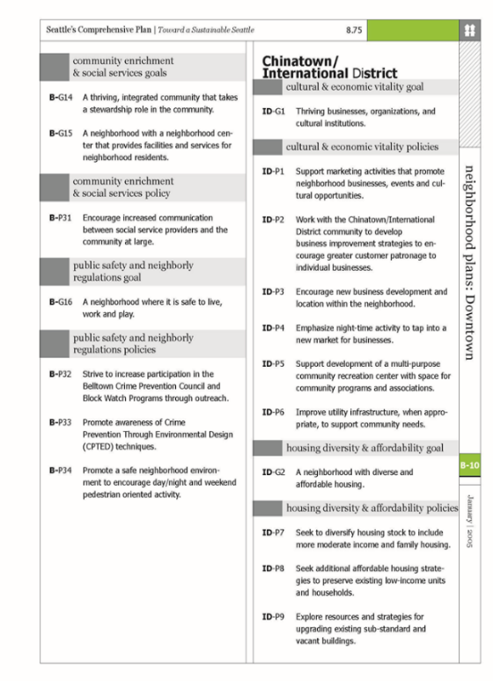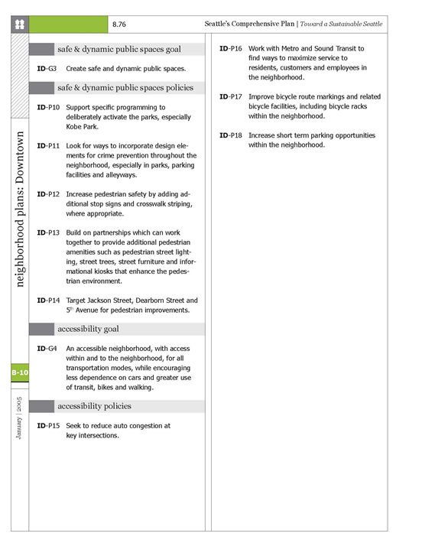
Figure 2: Asset Map of CID

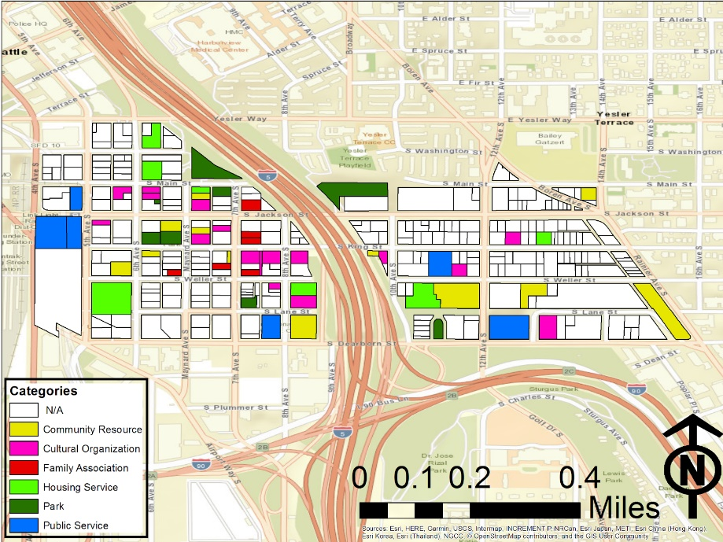

Figure 3: Housing Data
Household Income (2016 ACS) |  |  |  |  | Percentage
Under $25,000 | 203 | 428 | 429 | 1060 | 43.60345537
$25,000-150,000 | 263 | 511 | 469 | 1243 | 51.13122172
Over $150,000 | 16 | 72 | 40 | 128 | 5.265322912
Housing (2017 ESRI)
Housing Units | 664 | 976 | 1355 | 2995 | 1.470784641 | People Per Unit
Vacant Units | 58 | 28 | 84 | 170 | 0.9432387312 | Households Per Unit
Vacancy Rate | 8.73% | 2.87% | 6.20% | 5.67%

Housing (2010 ESRI)
Housing Units | 664 | 896 | 1060 | 2620 | 1.463358779 | People per Unit
Vacant Units | 33 | 57 | 87 | 177 | 0.9324427481 | Households per unit
Vacancy Rate | 4.97% | 6.36% | 8.21% | 6.76%

Figure 4: Ethnic and Age Breakdown: (Source: 2010 Census, 2016 ACS, ESRI)
